Wing Commander: Prophecy
Technical Design Document

Version 1.0 February 13, 1997
Hugh David, Jeff Grills, Jason Hughes
Frank Roan, Peter Shelus, Andy Sommers

Origin / Electronic Arts Confidential

DO NOT COPY

Table Of Contents
Table Of Contents 2
Project Overview 5
Target Hardware 5
Resources 5
Ship Date 5
SKU Plan Status 6
Category 6
Competetive Circumstances 6
Key Features 6
Why This Is An Origin Product 7
Existing Components 8
Game Engine 8
Rendering 8
Mission Editor 8
Mission System 8
Game Shell 9
Development Paradigm 9
Main Program Loop 9
Memory Manager 9
User Input Manager 10
Network Implementation 11
Movie Playback 12
Audio System 13
Rendering Engine 15
Graphics Layer 15
Texture Manager 15
Sorting 15
Culling and Clipping 16
Lighting 16
Software Rasterizer 16
3D Hardware Support 19
Rendering Pipeline 19
Game Engine Timings 23
Alias Converter 23
Flight / Physics Model 25
Dynamics 25
Flight Variables 25
Other Features 25
Ship Systems 26
Overview 26
Power Plant 26
Powered Systems 26
Engines 26
Guns / Missiles 26
Repair 27
Radar 27
Cockpit Displays 27
Communications System 28
Artificial Intelligence 30
AI Maneuvers 30
Maneuver Control 30
General AI Scripting 30
AI System Overview 32
VCR Playback 33
Mission System 34
Master Control Program (MCP) 34
Spaceflight 35
Gameflow 36
Transition System 37
Game Save Console 37
User Options Console 37
Simulator 38
Medal And Kill Scoreboards 38
Debrief System 38
Memory Usage 39
CD 39
System RAM 39
Risk Assessment 40
Network Support Risks 40
Windows 95 Risks 40
AI Risks 40
Audio Risks 41
Rendering Risks 41
Monthly Programming Task Summaries 43
January 97 43
February 97 43
March 97 44
April 97 44
May 97 45
June 97 (ALPHA June 5) 45
July 97 46
August 97 (BETA August 28) 46
September 97 46
October 97 (FINAL October 23) 46
November 97 (SIGN OFF November 6) 46
Detailed Programming Task Summaries 47
January 97 47
February 97 47
March 97 53
April 97 53
May 97 53
June 97 53
July 97 53
August 97 53
September 97 53
October 97 53
November 97 53
Appendix A – Scripting Language Specification 54
Appendix B – Mission Editor 57
Appendix C – A.C.E. Schedule 75
January 75
February 75
March 75
April 75
May 76
June (Wing: ALPHA June 5) 76
July 76
August (Wing: BETA August 28) 76
September 77
October (Wing: FINAL October 23) 77
November (Wing: SIGNS OFF November 06) 77

Project Overview

Target Hardware
Pentium 90
Local Bus or PCI Video (1 Megabyte for 8 bit color, 2 Megabytes for 16 bit color)
16 Megabytes System RAM
Digital Sound Card

Resources
Administration:
Rod Nakamoto Executive Producer
Dave Downing Producer
Frank Roan Project Director
Adam Foshko Associate Producer

Art:
Mark Vearrier Art Director
Weston Giunta Art Coordinator
Sean Murphy Artist
Pauline Saab Artist
Mark Leon Artist
Beth Pugh Artist
Dean McCall Artist
Damon Waldrip Artist

Programming - Game:
Pete Shelus Lead Programmer
Hugh David Programmer
Jason Hughes Programmer
Andy Sommers Programmer

Programming - Engine & Tools:
Jeff Grills Lead Engine Programmer

Video Production:
Jay Mahavier Post Production Supervisor

Designers:
Billy Cain Lead Designer
Ben Potter Designer
John Guentzel Designer

Audio:
Stretch Williams Audio Director
George Oldziey Composer

Ship Date
Projected Sign-Off: November 6, 1997

Projected Ship: November 1997

SKU Plan Status
Committed to Q3 1998

Category
Space Combat

Competetive Circumstances
Wing Commander: Prophecy targets existing Wing Commander fans and sci-fi action/simulation enthusiasts. The main competition will be from the Star Wars line of products from Lucas Arts, especially the release of X-Wing vs. TIE Fighter this year.

Key Features

Art
16 bit color for Spaceflight and movies
Dynamic lighting in Spaceflight
Realistic textures for space objects
Larger and more richly detailed Capital Ships
Improved Spaceflight special effects
Better cockpit HUD graphics and layout design
Real-time rendered (vector graphic and polygonal) cockpit displays
Spaceflight object creation using existing high-end Alias tools
Deeper and more thorough design process for object conceptualization
Compositing of CG sets with practical sets and actors
Syd Mead alien conceptual futurist
Introduction of new alien race
Introduction of CG aliens (character animation)
Ever increasing realism and improved effects for cinematics

Windows 95 Native Application
Full screen gaming using Microsoft’s Direct X
Hardware acceleration where available

Next Generation Render Engine
640 x 480 x 16 bit color Spaceflight
BSP tree algorithms for perfect sorting
Articulated, detachable child objects
Ambient, diffuse, and specular illumination
Flat and Gouraud shading
Light sourcing
Animated texture maps
Alias scripted camera paths
Scalable rendering

Advanced Mission System
Graphical tool for mission layout and scripting
Mission language for complex missions
Dynamics briefings and debriefings

Advanced Artificial Intelligence
Tightly integrated with mission system
AI to AI communications
Scripted maneuvers

Physics System
Force effects
Particle systems
Conservation of momentum
Enhanced flight dynamics

Advanced Sound System
Streamed digital music
Real time Dolby surround encoding
Doppler effect
Attaching sounds to objects

VCR Playback
Player controlled recording and playback of missions
Highlight reels for debriefings

New Cockpit Systems
New cockpit displays
Dynamic Multi-Function displays

Why This Is An Origin Product
Origin is credited for pioneering interactive movies with the Wing Commander line. More than five years after it was first released, the line is still a worldwide favorite and held as the benchmark in space combat simulations. Ensuing products – additional missions, spin-offs, and sequels – have only strengthened its reputation.

Existing Components

Game Engine
The game engine consists of all of the low level structural code. Currently, the majority of this code has been implemented. The game can set up timers, allocate and free memory, access input devices, read and write files, display fonts, and select the language to display.
Areas that still need to be implemented are as follows:

- Network support
- Audio layer
- Music streaming

Rendering
The rendering system is pretty much in place. The game can render to an arbitrarily sized display buffer, at both 8 and 16 bit color depth. The software rasterizer is fully functional. Individual objects and BSP sorted, and draw individually with no sorting errors. Sections that still must be implemented are or completed:

- Child objects sort properly with their parents
- Generate convex hulls to aid in dynamics BSP generation
- Object splitting
- True point lighting
- Alias object converter

Mission Editor
For the most part, the mission editor is complete. The editor is a completely generic editing tool that is configured for specific games via data files. Currently, the designers can create and edit Sector files, Mission files, Room files, and Series files. Objects can be assigned properties and mission programs. Mission programs can be written in FLO code and compiled. In short, fully functional Spaceflight missions and Gameflow scenes can be created.
The only tasks that remain for the Mission Editor (MED) involve implementing new mission commands as the need arises, as well as standard tool maintenance. Please refer to the appendix for further information regarding the Mission Editor’s capabilities.

Mission System
The mission system is also for the most part complete. MED missions are properly loaded, and game objects are properly created. Objects are places on the correct object lists, and mission programs are run and carried out.
Items that need further work include:

- Auto pilot sequences and Nav points.
- Additional mission command support as new commands are added to MED
- Statistics tracking

Game Shell

Development Paradigm
Although only a Windows 95 version of Wing Commander: Prophecy is currently planned, we are following a platform independent programming paradigm. Wrapper classes have been built around all the operating system and hardware specific portions of code, allowing each platform to access platform specific resources through a common interface. This allows all game specific coding to be used in identical form on all platforms, thus reducing the amount of redundant coding and significantly decreasing the time needed to port the game to another platform.

Main Program Loop
The main program loop basically consists of a single input manager (the IOWinManager) that services a stack of processes (IOWins). Every time through the loop, the IOWinManager assembles all the game’s input into event messages. These messages get passed down the IOWin stack. Each IOWin does as it sees fit with the message: either pass the message down, or keep the message to itself.
This system makes it very easy to add option screens, or navigational maps, or whatever. All that happens is a new process, or IOWin is created, and then placed on the stack. This allows the engine, for example, to drop an option screen on top of the currently rendering scene without halting the rendering.

Memory Manager

Functionality
Since this project is being developed in C++, the game uses the standard memory allocation and deallocation techniques of C++: usage of the new and delete operators is required while use of the older C style memory management functions of malloc() and free() is forbidden. The core engine overloads the global operators new and delete, passing all memory allocations through to the operating system abstraction layer by calling Os::alloc() and OS::free(). This has several advantages for the project including:

- Easier portability to other platforms.
- Ability to replace the memory manager at a later stage if needed.
- Ability to allocate a specified sized block of memory at game startup time. Then, using only that memory for heap allocation, we can assure that all systems that can initialize the game will always have enough memory to run the game.

C++ allows the new and delete operators to be overloaded on a class-by-class basis, when necessary. For speed and for avoiding memory fragmentation, the project has overloaded these operators for classes for which objects will be rapidly constructed and destructed. For example, the projectile class pre-allocates a large block of memory from which it manages the memory pool available for projectiles.

Debugging Features
Bugs related to memory management are notoriously difficult to detect, isolation, and resolve. This project has taken a unique pro-active approach to solving these problems early in the development cycle.
The debug versions of the overloaded memory allocation operators have extra features that help facilitate tracking down memory problems. The allocation function requests a larger block from the operating system that is actually needed to satisfy the request. This diagram indicates how the extra memory is utilized:

Header information (filename, line, size)
Guard region
User region
Guard region

The header information stores the filename and line number that requested the initial allocation. The guard regions are filled with a specific byte pattern, so that at deallocation time the patterns can be verified to be unchanged. The user region, which is used to satisfy the real memory allocation request, is also pattern filled with another specific byte pattern. When the memory is deallocated, the user region is again filled with yet another specific byte pattern. This extra data and pattern filling provides these extra debugging advantages:

- Detect memory leaks, specifying the file and line on which they occurred.
- Detect invalid intermixing scalar and array versions of new and delete.
- Detect attempts to repeatedly free the same block of memory.
- Detect the use of uninitialized memory.
- Detect the use of freed memory.
- Detect write over-runs on allocated memory at deallocation time.
- Detect write under-runs on allocated memory at deallocation time.

The debug memory tracking system has already detected each of these memory usage errors at least once so far during the development of this project. The cost of creating this memory tracking system has already been recouped through the time savings it has provided. The memory tracker provides a base level of confidence that there are no devious memory allocation problems in the project, allowing the company to ship this project with a much greater amount of confidence.

User Input Manager

DirectInput
The game engine uses Microsoft’s DirectInput in order to obtain raw input device values. Currently, the game has support for keyboard, mouse, and two axis, two button joystick input. The Mouse, Keyboard, and Joystick classes each query the operating system for the raw values for the device, translates the raw values into appropriate game engine low level input events, and then sends the events to the IOWinManager for distribution to game processes.

Input Device Consolidation
The Gameflow portion of Wing Commander: Prophecy makes use of a cursor, and is most intuitively controlled via the mouse. However, it is preferable to allow the player to use whichever input device they choose to move the cursor around the screen. This would be difficult to do if it was necessary to specifically code for every input device type, so the game engine has implemented the ability to consolidate input devices.
In other words, the keyboard, joystick, and whatever other devices we choose to add to the game can have their input mapped to the mouse. By doing so, the player can freely use whatever device they choose to move the cursor around, while in the game code, it is only necessary to respond to mouse events. This greatly simplifies the Gameflow code, and makes the engine much more flexible.

IOWinManager and Event Processing
All game engine low level input events are sent to the IOWinManager and queued. The IOWinManager keeps a stack of game processes (each game process is called an IOWin). Each of the queued events are passed through the IOWin stack. The top IOWin receives the event and determines whether or not to send the event down to the next IOWin. Once control is returned to the top IOWin (assuming the event had been passed down), or the top IOWin has decided not to pass the event down, the top IOWin responds appropriately to the event.
This type of setup allows us to easily bring up an option screen by adding a new IOWin to the top of the IOWin stack. It is guaranteed that there will be no input events inappropriately processed by any of the other IOWins on the stack because the event is never passed down to them.

Key Mapping
One more level of input event exists, known as the Keymap. The Keymap translates low level game input events from the keyboard, mouse, and joystick into high level game events such as Pitch, Yaw, Roll, and Fire. High level game events are queued up, and the systems responsible for responding to these events scan the queue and perform the appropriate actions.
The benefit of this type of system means that the Spaceflight game code refers only to high level game events. This makes the ship systems code much cleaner and easier to maintain. An additional benefit is the ability to re-map input devices to different game controls without the game code needing to know anything about it. As far as the Spaceflight systems are concerned, everything remains the same.

Network Implementation
There are two separate techniques currently under consideration for the data exchange paradigm for networked multi-player support for this project. These techniques will be referred to as synchronous and asynchronous. Their attributes are as follows:

Synchronous:
- Send a packet once every N game updates
- Identical simulations at all times
- Player control information
- Game-update loop locked (potentially video-frame locked too)
- Requires low latency, making Internet play difficult or impossible

Asynchronous:
- Send a packet as needed
- Varying discrepancies between the simulations depending upon latency
- Position, orientation, and control information for all objects owned by that machine
- Completely uncoupled
- Facilitates Internet play more easily

Technological issues exist with both approaches, and are summarized below.

Synchronous
The synchronous approach has some complications introduced by the constant-time (60hz) model update of our world simulation. The main loop causes the world to be updated, which in turn updates the simulation model a variable number of times depending on how much real time has elapsed, keeping the effective world-time synchronized with real-time. Since the number of model updates per rendered frame is variable, different machines will enter the network packet exchanging code at radically different times. A high level of latency is introduced that causes stalls and packet resends.

The synchronous approach can be easily solved if all machines are required to render at the rate of the slowest machine involved in the game, as was required by Wing Commander Armada. This approach would be the lowest risk, but be the least likely to please the customer in the end.

Another solution for the synchronous approach would be to update the world and exchange packets in real-time. This approach seems to require the use of multiple threads, which creates many more issues involved in thread synchronization and task-switching rates. This also greatly complicates debugging and development of the project.

Asynchronous
No programmer involved in the project has worked on an asynchronously updating multi-player game, so there are bound to be unforeseen complications.

An asynchronous approach to multi-player requires communication of significantly more information to be transmitted across the network medium to help recover from discrepancies in the simulation. A fair and viable approach to doing asynchronous updating is utilizing a client-server system, with the server being authoritative for collisions, damage, and kills. The server, freed from graphical representation of the world, should be able to handle several concurrent simulations at once. However, for small networks where a machine cannot be dedicated to running a server, the server will need to run on the machine of one of the players. Use of a server in asynchronous updating also increases the company’s ability to create on-line financial opportunities.

Dead-reckoning schemes will have to be put into place for all objects. Many objects will be easy to cope with, since they follow basic constant-velocity paths unless collision detection deflects them. These objects will only need to communicate their current life state, their position, their orientation, and their velocity. Controlled objects, such as player ships, AI controlled ships, and smart missiles will have to communicate much more information, for instance their immediate control information (desired yaw, pitch and roll), along with more life state information such as damage.

Dead reckoning will be able to take advantage of the constant model update to increase accuracy. When transmitting data, the sender will include the world model update number in the packet, indicating an implicit time stamp. When a client receives a packet, the object can be placed in exactly the location specified in the packet, and then that object will have iterative applications of its update applied to it until the object is projected forward into current time on the client machine.

The server machine will need to keep a history of the position and orientation of all objects. When the server receives an update from a client, the server will follow the above algorithm to project the object into the current real time, checking for collision against the appropriate old locations of the objects.

Data Communication Scheme
The data communication code for this project has been designed to be reusable across multiple projects. Remote players are represented by NetworkClients. Every NetworkClient has a NetworkLink that has all the necessary information to be able to send data to the remote client. The engine will provide different NetworkLinks for the various communication media that are supported by the host platform, specifically for a Windows95 host the expected NetworkLinks will include support for IPX, IP, and serial communication lines. The Network class is responsible for managing a list of NetworkClients and their associated NetworkLinks in order to allow one copy of the game to communicate with all other interested parties. Multiple NetworkClients may share a single NetworkLink. For instance, if a single player is dialed into a game server and is playing against 4 other players, there will be four NetworkClients that all use a single NetworkLink.

This technique is very similar to the proven technique used in the 8-player IPX patch Proving Grounds for Wing Commander Armada.

Movie Playback
Wing Commander: Prophecy will be using Xan. Xan was used in Wing Commander IV, and provides excellent visual quality with a nice compression rate. Xan will be modified slightly in order to fit in more nicely with the game engine. Using Xan will reduce the risks associated with implementing a movie player almost to zero.

Audio System
The current design for the audio system is composed of two major components: streamed digital music and dynamically mixed digital sound effects.

Streamed Digital Music
The streamed digital music interface will be very simple, but incredibly flexible. The music will be broken down into tracks and events. A track is a long continuous portion of music, much like a song. Events will be shorter pieces of music that are linked to specific game events that are invoked much like subroutines. In order to describe their relationship to each other, it is first necessary to understand the manner in which audio data will be processed. The audio data will be read in blocks of atomic frames. The end of each frame will contain two tables that indicate how the music may be changed at that point: one table for event processing and a separate table for track processing. If a musical event has been requested and the table contains a valid frame number for that event, the audio system will branch to that audio frame and continue processing until the branch ends, at which point it will return to the frame that initiated the branch. If the event returns and another event has been posted, that new event will be immediate processed. When event processing is complete, the audio system will index the track table with its currently requested track number, and processing will continue at the specified audio block.

This simple interface allows musicians to lay out potentially complex audio streams with transition pieces between requested tracks. It also allows them to selectively enable music subroutines at any location. Musicians will likely divide the audio into frames at beat boundaries, allowing seamless transitions between all music in the game.

Digital Sound Effects
Dynamically mixed digital effects will be implemented using several layers. The lowest layer is a sample, which will contain waveform data that indicates the actual values to mix into the audio stream. A sound will be an instance of a sample, either currently playing or stopped. The sound will contain all the necessary data in order to make an appropriate noise– the sample, volume, pan, and location of the sound. This system allows samples to be shared amongst several sounds, reducing memory requirements and load times. A sound will also be able to have a vector position in 3d space, or it may be attached to an object in motion. The audio system will keep a list of all sounds that are actively playing. Since we are unlikely to be able to have an unbounded number of sounds playing simultaneously, the list will be kept in a sorted priority, and the mixing system will handle as many as it can.

Low Level Implementation
The sound system will be based on top of Microsoft’s DirectSound interface, utilizing as much hardware support as can be achieved. This low-level implementation will take the streamed audio frames and mix in the dynamic digital effects to create an impressive audio experience for the consumer.

Font System
The Font System is designed to handle all of the text output in the game. In order that this be as simple as possible, the Font Class provides a high-level interface. The current font system allows for proportional spacing, as well as colored text.
Fonts are generated by rendering a True Type font into a bitmap, and then extracting the individual characters into the game’s native bitmap font format. Currently, the game engine only supports fonts that have already been converted offline via a font conversion tool. Ultimately, it will be possible to render a True Type character set and convert it at run time, making it very easy to support arbitrary video resolutions. This will most likely not be implemented in time for use in Wing Commander: Prophecy.

Language System
The language system allows the game to be easily translated to other languages without requiring a rebuild of the game. It is based on the LanguageFreedom system used in Wing Commander IV and the translation tool used for Kilrathi Saga. This is a very simple system. A single file contains all of the text strings that are used in the game. Inside the code, a programmer may use a string by specifying the offset into the data file. These offsets are macros, and are given intuitive names, so that they are easy to use. The current system does not implement 2 byte character sets, but the design of the system has expansion in mind.
This section has just been briefly touched in this document due to time constraints.

Rendering Engine

Graphics Layer
This year, 3d accelerator cards are becoming common in consumer machines. Many manufactures are creating many different cards, all with incompatible application programming interfaces. In order to take advantage of as much of this new hardware as possible, the graphics hardware interface code has been moved into a dynamically loaded library. This dynamically loaded graphics library is called a GLL. By creating a GLL for each hardware card that is supported, the project can maintain a consistent and clean interface to all the graphics drawing primitives and support as many of the various 3d accelerator cards as development time permits.
This unique approach has an amazing advantage. After the game has shipped, a new GLL can be developed to support new hardware. This GLL can then be placed on FTP sites or WWW sites for download by the consumer. In this manner, we can provide customers with native support for new hardware that is created even after the project has been completed. In addition, this will make it easy to create a GLL for a hardware manufacturer that would like to bundle the game with their new hardware.
The graphics abstract layer is implemented as an abstract base class in C++, so every function is called through a virtual method table. Thus, the GLL only needs to export three functions through the windows DLL interface to the game: InitGL(), CreateGL(), and DestroyGL(). This allows code development for a GLL to be very similar to code development for the rest of the game.

Texture Manager
Using the GLL abstraction, on-card texture management is the responsibility of each separate GLL. For cards with limited texture memory, a Least-Recently-Used replacement scheme will be the basis for each of the texture management schemes. This scheme will be augmented with another system (most likely just the inclusion of a random offset) to prevent the pathological case of N textures being used in a scene when only N-1 textures will fit into VRAM, thus each new texture would cause a replacement. If a GLL has limited texture space, we can expect that the card has at least 2mb of total ram, approximately 1.2mb of that will be dedicated to the frame buffer and back buffer, leaving approximately 800k for textures. If textures are loaded into 256x256 blocks (a size chosen because it is small, square, and its dimensions are a power of two), we may have 13 textures simultaneously loaded.
High-level texture management is done by the designers and by the artists. Designers carefully construct missions to avoid having too many different ships in one region of space, thus reducing the number of textures possible within a single scene. Although the engine does support multiple texture blocks per ship (in fact, one per polygon is allowed), artists will be constrained in their texture usage. Artists use one texture block of 256x256 per fighter. For large ships that will require multiple texture blocks, artists will subdivide the object using BSP splitting planes, and constrain themselves to using one texture block per BSP sub-node. This will minimize the number of texture state switches while rendering large ships, while still allowing additional texture space.

Sorting

Static Per-Object BSP Trees
Each polygonal object has a BSP tree associated with it. This tree serves as a pre-calculated visibility tree, and allows each object individually rendered in Wing Commander: Prophecy is drawn with zero sorting problems. One last feature that still needs to be implemented is the ability to properly insert child objects into nodes of the parent’s BSP tree so that they sort properly. Artists will be able to predefine a set of initial BSP splitting planes that will allow them to insure that child objects will be contained within a single sub-node of the BSP tree. This guarantees that the object will not need to be dynamically split in order to draw in a correct sort order. However, this will require that the rendering engine will be able to render a second object while in the middle of rendering a first. While this code change will be tedious, it should not be difficult.

Dynamic Per-Frame BSP Trees
Every render frame, the rendering engine builds a dynamic BSP tree in order to separate and properly render all of the visible objects. Currently, the engine considers all objects to be spheres. Two objects are chosen, and a line separating the two objects is determined. A BSP plane is positioned at the midpoint to the line, perpendicular to it. The plane can slide up and down the line if the midpoint plane intersects any other object spheres. This is done until all objects lie completely in a convex region of space.
This is not the final implementation of the dynamics BSP generator. It is possible for the BSP splitting to fail. Support for cylindrical objects will be added, as well as convex hulls for each object. If a plane cannot be easily found to be placed between objects, the engine will resort to using a face from an object’s convex hull.

Culling and Clipping
Rapid object culling has been implemented using a standard test of the object’s bounding sphere against the planes comprising the sides of the view volume. Polygon clipping uses a 3d extension of the standard 2d Sutherland-Cohen clipping algorithm.

Lighting
The game engine lights objects according to vertex normals for Gouraud shading, and according to face normals for flat shading. These calculations are the standard dot product to scale the intensity value for that face or vertex.
All lights in the game engine are specified as RGBM quads. A monochromatic (intensity) value is either explicitly stated in the M field at the time of creation, or M is calculated from the RGB triple. Software rendering only makes use of the monochromatic intensity value. Colored lighting is just too slow in software. If 3D hardware supports colored lighting, the RGB value is used for lighting. If colored lighting is not supported in hardware, the monochromatic value is used. Currently, the engine supports ambient, directional, and point light sources.
Ambient is the simplest and least computationally intensive form of lighting. An ambient light affects all objects in the same manner, by applying the same lighting value to all objects regardless of the objects’ positions or orientations.
Directional lighting is the next least expensive lighting model, because it is based solely on an object’s orientation with respect to the light’s direction. In order to illuminate an object with a directional light, the light’s direction vector is dotted with each face normal (for flat shading), or with each vertex normal (for Gouraud shading) in order to determine the intensity values.
Point lighting is the most expensive because it is dependent on an objects orientation as well as position. The exact same calculations are performed as in directional lighting, except the intensity is scaled based on the distance of the face, or vertex from the point light source. Currently, the game engine implements point lighting in a less expensive, although less accurate method. The vector from the light to the object being lit is used as the incident lighting vector. Vertex calculations use this vector, rather than computing an incident lighting vector for each vertex. Ultimately, the more expensive method will be implemented as well. The plan is to implement an optimization that will allow the game engine to detect instances when we can use the simplified point lighting model. Point lighting will be used sparingly, if at all in Wing Commander: Prophecy.
An issue that still needs to be resolved involves detail levels. Each polygonal object actually consists of a number of separate meshes, with each mesh becoming progressively less detailed. As the meshes become less detailed, the lighting can change drastically since lighting is very dependent on geometry.

Software Rasterizer
The 3D rendering system uses a software rasterizer written by David Wu especially for the new engine. This texture mapper is significantly faster than any that Maverick Productions has ever used, and blows the doors off of Direct 3D’s software rendering. Below are excerpts from the rasterizer documentation provided by David Wu.

Excerpts From Rasterizer Documentation
Raster is a system designed for the real time rendering of polygonal primitives. The design goals of raster are as follows:

Performance
Quality
Ease of Use

The primary target environment of raster is:

P54c/P55c (Pentium/Pentium with MMX)
16 bit RGB display device
Textured-mapped, Gouraud-shaded polygons
No (or poor) hardware 3d graphics acceleration

Measured Performance:

7.0 million Gouraud lit, perspective texture mapped, 16 bit pixels per second
Pentium 100, ATI Mach64, no hardware acceleration.
( 23 fps @ 640x480x16 )

Raster supports the following:

Target Surfaces:
16 bit palletized
8 bit RGB (any combination)

Source Geometry:
N-sided convex polygons

Source Surfaces:
Textured (8 bit palletized)
Single color

Mapping Modes:
Perspectively correct
Affine

Shade modes:
Flat
Gouraud (with or without perspective correction)

Miscellaneous:
Target surface clipping
Texture tiling
Wire frame
Sub-pixel accuracy
Specular Highlights

draw_poly timings

Inner loop clock cycle counts are listed for each primitive. The validity of these counts depend on the following requirements:

- The processor is a Pentium / Pentium with MMX
- All code is in the code cache
- All branches are accurately predicted
- There are no data cache misses

Requirement 2 is largely dependent on the 3d pipeline.
No single primitive has 8k (16k for MMX) of code associated with it.

Assuming polys are relatively large, requirement 3 will usually be met in all primitives except those with transparent textures.

Requirement 4 depends on the following:

Texture Reads:

The number of unique texels accessed by the primitive
The coherency of these accesses

Remarks:
large dv/dx’s will have a greater penalty than large du/dx’s

this penalty does not apply to un-textured polys

Clut Reads:

The number of unique shade level’s traversed by the primitive.
The number of unique color table entries traversed by the primitive.
The coherency of these accesses

Remarks:

lower values for shade_bits will reduce this penalty
flat shaded polys only access one shade level (clut row)
un-textured polys only access one color table entry (clut column)

Target Surface Writes:

In most environments, these will happen in parallel with the rasterization
The rate of these writes varies widely from system to system
On clock * 1.5 systems, (P-100/P-90) with 64 bit DRAM/VRAM PCI video cards, writes will not usually limit the texture-mapped primitives (which run at around 8 clocks/pixel)

Target Surface Reads:

The translucent primitives must perform target surface reads during rasterization
Video Memory reads can cost over 70 cycles to execute. Although the inner loop timings for the 16-bit translucent primitive is 2.5 clocks, it does a target surface read every 0.5 pixels, thus requiring about 37 cycles per pixel.

Primitive Timings
Perspective corrected, linearly shaded, texture mapped
8 bit 16 bit 8 bit transparent 16 bit transparent
inner loop cycles per pixel: 7 8 8/6 9/6

Affine mapped, linear shaded, texture mapped
8 bit 16 bit 8 bit transparent 16 bit transparent
inner loop cycles per pixel: 7 8 8/6 9/6

Perspective corrected, flat shaded, texture mapped
8 bit 16 bit 8 bit transparent 16 bit transparent
inner loop cycles per pixel: 7 8 8/6 9/6

Affine mapped, flat shaded, texture mapped
8 bit 16 bit 8 bit transparent 16 bit transparent
inner loop cycles per pixel: 7 8 8/6 9/6

Perspective corrected, linearly shaded, solid
8 bit 16 bit
inner loop cycles per pixel: 5 5

Affine mapped, linear shaded, solid
8 bit 16 bit
inner loop cycles per pixel: 4 4

Affine mapped, flat shaded, solid
8 bit 16 bit 8 bit translucent 16 bit translucent
inner loop cycles per pixel: 0.5 1 4 2.5 (37 with video read)

3D Hardware Support
The GLL currently expects the game engine to do all transformation, clipping, and projection of all polygons. This approach will prevent the engine from taking advantage of any hardware geometry acceleration that may come into existence, or using any cards that require unprojected polygons. This limitation has been deemed too severe, and a reworking of the GLL interface has been put into the development schedule.

Since we cannot expect every GLL to provide correct sorting for the game, the BSP implementation supporting child objects will need to remain in the engine. The game engine will therefore always need to do the object processing, generating a list of polygons for the GLL to process. The rest of the 3d graphics pipeline should then be implemented within the GLL.

The GLL will need to be able to process polygons in object space, transforming, clipping, and projecting them into the view plane. The software rasterizer GLL will be able to use all the existing code by simply reordering some of the steps and moving the code into the appropriate GLL. For different hardware accelerators, new schemes of transforming, clipping, and projecting may be able to use a copy of the software rasterizer GLL’s code, or it may need specially written new code. The more functions of the 3d pipeline the card accelerates, the less code will be needed in order to glue it into the existing GLL structure. This implies that less and less programmer work will be required as hardware becomes more functional. A driver that implements a complete 3d graphics pipeline, such as that provided by OpenGL, should require very little effort to integrate into the engine. In fact, implementing an OpenGL driver for this engine will likely be the best way to determine if the line between the engine and the GLL has been appropriately positioned.

Rendering Pipeline
Every update loop, the IOWinManager goes through each of its “windows” and sends a draw command to it. In the case of the World, the draw command instructs the window do render the camera list for the world. Within this camera render occurs the 3D rendering of objects, the background star fields and dust fields, the cockpit HUD, everything that gets drawn on the screen.

The following charts document the flow of control in order to draw a single frame in Spaceflight. Note that the chart starts with “Draw Frame”. The second set of charts are “magnifications” of the systems glossed over in the first set of charts.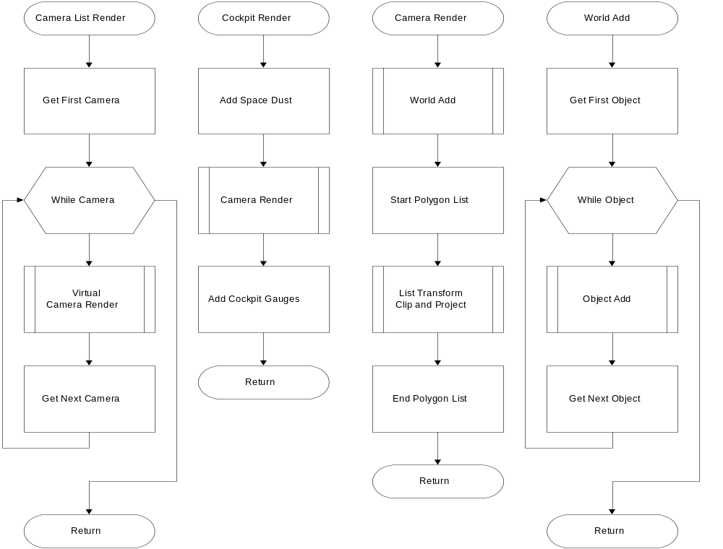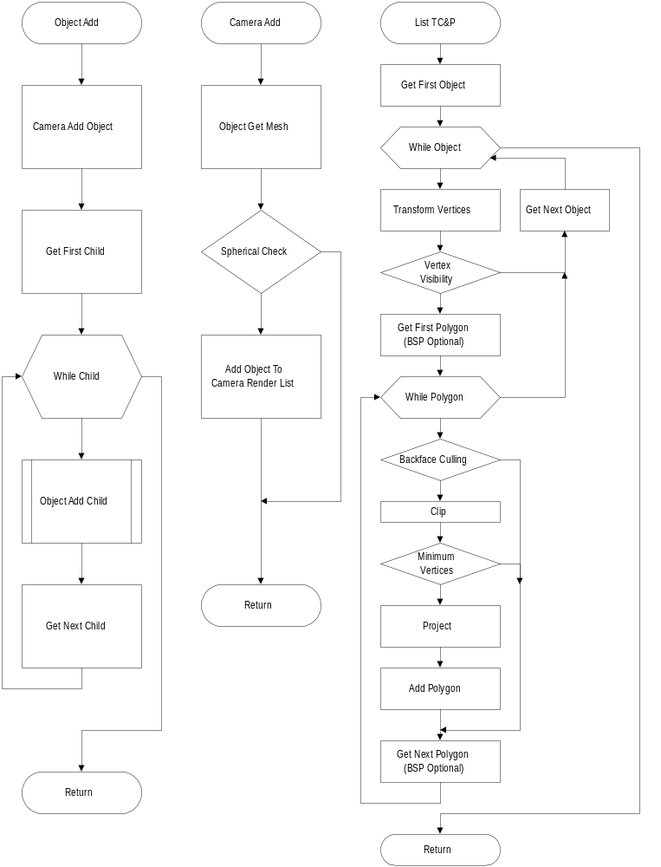
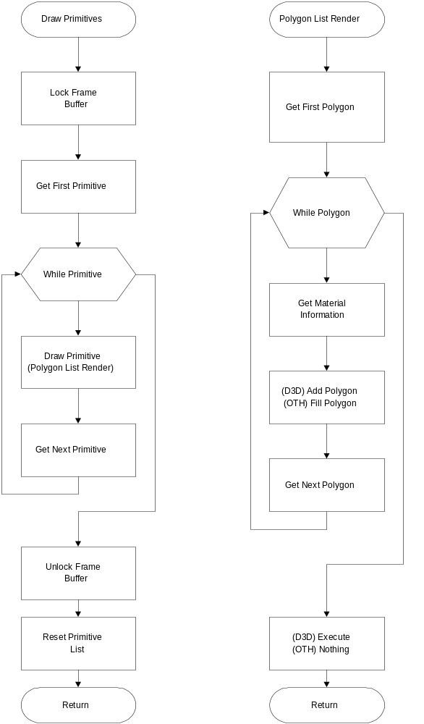

Game Engine Timings
Note: All timings done on a P90 with a “typical” Windows 95 setup (hardware page flipping, hardware bitblt). Polygons were rendered in 16 bit color, with perspective correct Gouraud shading and texture mapping.

Capital Ship
- 30% draw
- 291 input polygons
- 120 output polygons (292 triangles)
- 2 directional lights

Raster | width | height | depth | back buffers | fps
Wu | 320 | 240 | 16 | 2 | 55
Wu | 512 | 384 | 16 | 2 | 36
Wu | 640 | 480 | 16 | 2 | 27
Wu | 800 | 600 | 16 | 1 | 20
Wu | 1024 | 768 | 16 | 1 system | 5.8
3dfx | 640 | 480 | 16 | 1 | 51

Box Interior
- 100% draw
- 24 input polygons
- 12 output polygons (28 triangles)
- 2 directional lights

Raster | width | height | depth | back buffers | fps
Wu | 320 | 240 | 16 | 2 | 55
Wu | 512 | 384 | 16 | 2 | 26
Wu | 640 | 480 | 16 | 2 | 18
Wu | 800 | 600 | 16 | 1 | 12.25
Wu | 1024 | 768 | 16 | 1 system | 4.2
3dfx | 640 | 480 | 16 | 1 | 60

In the game, we are currently able to render at a rate up to 5.7 million perspective correct Gouraud-lit and texture mapped 16 bit pixels per second (18.5 fps at 640x480x16). This figure was obtained by running Wing Commander: Prophecy on a P90 with both the front and back buffers in VRAM, rendering with the camera within a cube, resulting in 100% screen coverage with no overdraw.
It is planned to implement an optimization that will determine how “perspective” a polygon is. This way, the game engine will be able to select the appropriate grid size for perspective correction, or even just render with the affine mapper.

Alias Converter
All polygonal objects for Wing Commander: Prophecy are being created in Alias. This is optimal because the artists can generate meshes much more quickly if they are using a utility that they are familiar with. Additionally, it means that the development team doesn’t need to waste time writing and maintaining an object mesh editor.
The converter currently converts an Alias mesh into the format used by the rendering system, as well as generate a BSP tree for sorting purposes. Features that are to be added include:

- Seeding the BSP tree with initial planes
- Specifying hard points for guns and missiles
- Positioning and assigning child objects
- Consolidating detail level meshes in one file
- Generate a convex hull for each object
- Animated textures

Flight / Physics Model

Dynamics
Wing 3 and 4 lost the feeling of realism that was in the first two incarnations of the game. Wing Commander: Prophecy implements a dynamics model that brings back that feeling of Spaceflight.

The physics model is basically simple Newtonian physics. Each object is described with a mass and a velocity. Forces and torques act on the objects, generating linear and angular accelerations according to the equations F = m * a and T = I * alpha. In order to keep the feeling of Wing Commander, these models are being modified by what can be thought of as “inertial dampeners”.

Spaceships in the Wing Commander universe are supposed to move generally in the direction they are facing. In order to do this, the thrusters on the ship attempt to compensate by applying accelerations in order to keep the ship’s velocity vector pointing in the same direction as the forward vector. Because the ships have limited acceleration capabilities, an afterburning ship can experience an “afterburner slide” by rotating their ship.

Flight Variables
Here are the parameters that designers will be able to set in order to define a particular spaceship type’s flight characteristics:

- Mass
- Moment of Inertia
- Maximum yaw rate
- Maximum pitch rate
- Maximum roll rate
- Maximum velocity with minimal (0%) input from power plant
- Maximum velocity with average (33%) input from power plant
- Maximum velocity with maximum (100%) input from power plant
- Maximum afterburner velocity
- Maximum force
- Maximum torque

Maximum velocity for a spaceship is dependent on the amount of energy input from the power plant. Designers will specify three control points to maximum velocity based on 0%, 33% and 100% power input. A quadratic (smooth) curve is computed between these three control points so that when the player adjusts the power input to the engines (thrusters), the resulting maximum velocity will track a smooth curve, yet still allowing the designers complete control of the spaceship’s maximum velocity.

Other Features
Ultimately, we will be implementing a relatively realistic collision resolution system that will cause proper rotations and translations due to collisions or nearby explosions. Also, by modeling motions via forces and torques, it is possible to create interesting objects in space like gravity and ant-gravity objects, shock waves, etc.

Ship Systems

Overview
Every spaceship in Wing Commander: Prophecy has a power plant associated with it. It is the only required system for a ship. Designers then attach various powered ship systems to this power plant in order to add functionality to the spaceship. By doing so, it is possible have damage to the power plant effect all ship systems, easily reproduce the effect of the “Leech missile”, as well as have various ship systems steal power from the remaining systems.
These sections have each been only briefly touched in this document due to time constraints. Each of these systems have already been implemented, with the exception of the missiles, which are remarkably similar to the guns.

Power Plant
The ship’s power plant holds a list of all the powered systems attached to it. It keeps track of the percentage of power to send to each of these systems. Every update, the power plant distributes the power based on its operating efficiency.

The power plant provides the ability to dynamically alter the percentages of power sent to the various systems. Raising the percentage given to one system will proportionally reduce the percentages sent to the remaining systems. An exception to this rule is for “locked” systems. The power plant can lock a particular system so that changes made for other systems will not effect the amount of power being sent to the locked system.

Powered Systems
All of the optional ship systems will derive from the PoweredSystem class. This class holds the information regarding the size of the energy pool, the amount of energy in the pool, as well as the equation for converting power plant energy into powered system energy. By deriving all ship systems from the PoweredSystem class, we guarantee that the systems are “power aware”.

The PoweredSystem class also keeps track of the current damage state of the system. It is the responsibility of each specific system to use the current damage state to effect the efficiency of the system.

Engines
A ship without engines cannot move. The thrusters provide a ship the means of applying linear and rotational accelerations in order to effect rotation rates and velocity. The engines provide information regarding maximum velocity, and afterburner fuel, the rotational rates, as well as afterburner velocities for a particular ship. Engines derive from PoweredSystem and are configurable via the Power Plant.

Guns / Missiles
These two systems define the offensive capabilities of a spaceship.

The gun system derives from PoweredSystem and collects power from the power plant in a “gun pool”. Energy from this gun pool is used for firing the energy bolts. The system can shoot one particular gun array (activeArray), or all gun arrays at once (fullGuns). An additional feature is the “linkedGuns” flag. This allows the guns in a single array to fire at once (linked firing), or fire in an alternating pattern (unlinked firing). The guns are placed on hard points, which are positioned by the artists with Alias, and are stored in the ship’s mesh file.

The missile system works in a very similar manner as the gun system, except the missile system does not keep strict tabs on the amount of power available in the pool. This system only cares that there is SOME power going to the system. Missiles are also placed on hard points.

Repair
The repair system determines which of the ship systems are damaged, prioritizes the repairs, and then begins repairing the most important and most damaged systems. Once a particular system has fallen to zero damage points left, the system is considered destroyed and repairs cannot be made to the system. In order to simplify the game for the player, the repair priorities will be hard coded. This will also prevent the need for writing a user interface to interact with the repair priorities. Repair derives from PoweredSystem and is affected by power loss.

Radar
The radar is the most standard of the Wing Commander gauges. The radar gauge is already implemented, but it still needs to have the details worked out regarding friendly / enemy targets, as well as simple z-sort occlusion to allow things to hide in asteroid fields.

Cockpit Displays

The Cockpit data format
This data format has been used in previous Wing Commander games to great effect. Although we will be updating certain game sub-systems, such as the issue of language and localization, we will still be able to use XMIFF for the cockpits in Wing Commander: Prophecy.

Risks / Issues.
One sub-system which is changed from previous Wing Commander games is that of the video output, and as such, the problem of drawing cockpit bitmaps is for the PC version is integrated with rasterization either within DirectDraw or on hardware-accelerated cards. Additionally, line draw cockpit displays will be used when appropriate in order to speed up cockpit draw time as well as save memory.

Another sub-system change which will impact VRAM usage is that of the 3d Targeting Camera. Since the current plan is to display targets in the VDU’s via the 3d system, using their 3d models, this will save additional memory since we won’t have to load multiple bitmap images to display the target VDU.

Following is an example of an XMIFF file containing the description of a simple cockpit. For a description of the XMIFF utility and data format, see the file XMIFF.DOC.

FORM COCK
{
// target shape packet file name
CHUNK TARG
{
char[8] "blutarg"
long PLAQUE_HAZE_TABLE
}
FORM SVGA
{
FORM HUD
{
CHUNK VPRT
{
long 0,0,639,479 //size of visible viewport in this view
}
CHUNK RADI
{
long 12 // inner radius (itts aligned)
long 125 // outer radius (missile lock enable)
}
CHUNK VDU
{
byte NO_DAMAGE // no damage in HUD view
long 35,375 // vdu 0 shape location
long 35,375 // vdu 0 data location
long 120,100 // width,height of display area
}
CHUNK SYS
{
// vdu 0 assignments
byte SYSTEM_PLAYER_SHIELD
byte DAMAGE_SHIELDS
long 0 // vdu assignment
long 1 // default display status
}
CHUNK WEAP
{
long 2 // number of gun hardpoints
long 21,20
long 25,8
long 2 // number of missile hardpoints
long 6,80
long 14,73
}
CHUNK TARG
{
// HUD clipping region - use -1 to indicate entire screen
// long 36,97 // top left coordinate of HUD clipping region
// long 581,479 // bot rght coordinate of HUD cliiping region
long -1,-1
long -1,-1
long S_TARGET_ICONS_SHAPE
long S_TARGET_MISS_LOCK_SHAPE
}
} // end form SVGA
} // end form COCK

Communications System

Communications Overview
The comm system is the medium through which pilots send messages to other pilots. All messages that coordinate ships not currently in formation, that the player can see as a direct or indirect receiver, or that the player sends personally, are routed through this class. Many do not require the playing of VDU movies, some do. Only those which involve the player necessarily do, though it is possible to have a listening device which allows the player to receive all comms, or selective comms, if the designers so choose to ask for one.

System Design:
When AI calls for a message to be sent to another ship, either as a part of a maneuver, part of a script mode command, or as a response to another comm inquiry, an event is generated and placed on the Group comm list. Each update, each ship will check his personal comm event list and will respond to the sender in an appropriate fashion. Sometimes this is will an action, other times with a comm back to the sender.

Wing leaders will be the communication heads in space--no wingmen will ever directly communicate with the wingmen or wing leaders of another group, although they can send messages to anyone within their own group. When inter-group communications occur, the message is addressed to only the wing leader. Any information needed by the wingmen from the comm sent to the wing leader will be sent through ancillary comms or through direct formation command directives by the wing leader.

Group-to-Group Example:
Aristotle Class Wing Leader: sends, “Gargoyle Fighter Squad Wing, escort us to the jump buoy.”
Gargoyle Fighter Squad Wing Leader: receives. Runs Escort program, which sends, “Roger Aristotle, coming about.” Escort sets course to fly near and defend Aristotle, telling his wingmen to stay in formation and defend Aristotle.

However, inter-pilot communications are necessary for fun and hassling during the game, so the player has the ability to address individuals within a wing, rather than solely the wing as a unit. This is normally only given as Taunt Target commands or as wingmen directives like Attack My Target or Defend Target, but the system is capable of allowing the player to address any object in space as an individual entity.

Implementation
The AI system contains a data structure called Groups. Each formation in space has one that describes all the members of the group, provides an iterator function, search capability, and other statistical and tracking functionality. Currently, there is no routing function implemented yet, as functionality is not fully determined. When design is complete for missions, a system will be inserted in the Groups class which takes a communication structure that declares the sender, receiver, content of the message, movie to display in case the player receives it, and audio file to play in case the player hears it. The routing function will immediately place the communication structure in the member’s data structure in a linked list, to be read and interpreted upon the next update.

Artificial Intelligence

AI Maneuvers
This system is currently in a state of design, so any information listed here is preliminary, and subject to change as research and development show fit. Primarily used as unscripted responses to exterior stimuli, maneuvers are a means for delivering a more human-like feel to ships while performing their duties as assigned by the designers. They relieve the burden of scripting combat to the actual capabilities of the craft, the pilots, and the odds against each.

Maneuver Control
Each ship will be allowed a certain set of maneuvers it can carry out, defined upon loading the object data. Not all ships have access to all maneuvers, as not all rookie pilots know the most advanced moves, nor can they execute them effectively. For this reason, each ship maintains data on the maneuvers it can execute.

Some limited data accumulation may be taken over the course of the game which profiles the player’s abilities and reactions against all maneuvers. This profile will aid in setting pilot difficulties, especially in the case where one pilot should be amazingly difficult to defeat, we can simply select the maneuvers the player cannot defend against as readily as others.

General AI Scripting
It should be noted that the maneuver system is not related at all to the actual scripting of the missions. Any combat, conflict, or computer-controlled and non-scripted activity is a maneuver. Simple commands such as GotoRelative(object,x,y,z) is not considered a maneuver, as that command would be explicitly scripted by the designer. When a ship’s AI determines a threat, hazard, or any other necessary change in the explicitly specified programming, AI then supercedes scripting and takes control of the ship and all its functions (called AI mode). Upon completion of AI mode, the ship returns to script mode, and resumes programming where it left off.

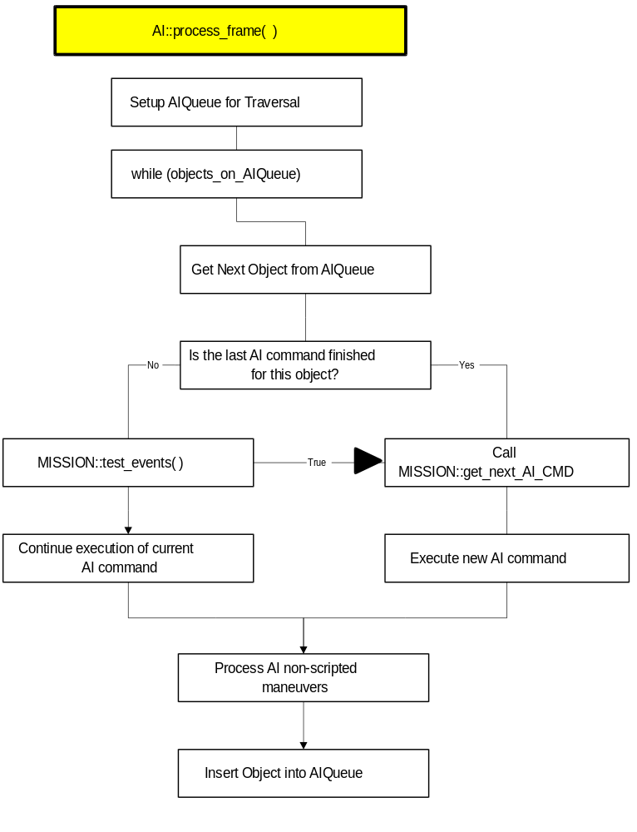

AI System Overview
The AI system is called once per frame. Currently, this is 1/60th of a second at a fixed world model update rate, guaranteed regardless of the frame rate. Each ship that needs an update that frame will be removed from the AI scheduler and have its Process() function called. At the end of the Process() the return value is a time lapse to set from the current frame to the next update frame, based on the sort of work being articulate in the ship’s AI. This staggers the updates so that even with several hundred ships in space, few will be updating at any given frame.

VCR Playback
Wing Commander: Prophecy will have the ability to record and playback Spaceflight missions. The fact that the game is being developed to have a constant model update rate significantly reduces the difficulty in implementing this system. Since we know what the model update rate is, we can guarantee that playback of VCR files will be identical on all machines, regardless of machine speed.

In order to record a mission, at the start of the mission the VCR system will begin by recording the initial random seed (or seeds), thus forcing our “random” numbers to be deterministic. Then, the system will start tracking the control structures of all objects in the world. These structures will be compressed so as to conserve memory. In order to playback the VCR file, just reload the mission, initialize the random seeds, and start inserting the appropriate recorded control structures into each of the spaceflight objects. The mission will replay precisely the way the user played it.

Here are some of the many possible uses for the VCR playback system:

- Programmers can get recorded VCR files from testers in order to pinpoint bugs and crashers
- Player can review their mission with standard VCR controls, as well as switch the viewing perspective.
- During the mission briefing, we could have highlights of the just flown mission playing in the background with a voice over.
- We could use this option as a animated background filler behind option screens, or as examples of what needs to be done during the mission briefings or training sessions.
- The credits could roll over some previously recorded space combat.
- This would be an excellent for recording demos to show off out game engine for in-store and show floor demos.
- The mechanics of the VCR system would aid in the implementation of a network system.

This section has only briefly been touched in this document due to time restrictions. The VCR playback system will make use of the Multi Player System’s ability to store and transmit control, orientation, and position packets.

Mission System

Master Control Program (MCP)
On the game side, there will be a Program class interpreting the FLO program scripts created and compiled with MED.

When the programs are “run,” or interpreted, the current design is to have the appropriate system (the MCP Scripting System, the Gameflow Scripting System, the Spaceflight Scripting System, and the AI) call the get_next_command () function. This function will parse the compiled code block, determine the course of action, increment the instruction pointer, and pass that instruction to the appropriate system. This will continue until the program has been completed, or halted by another program.

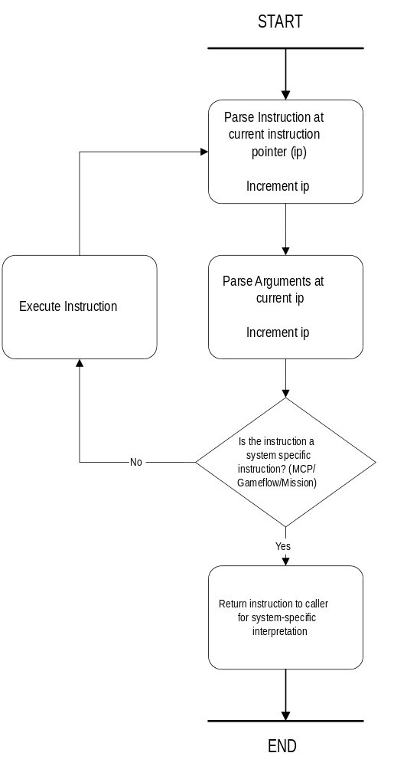
Figure 1 : In-game Program Parser
The MCP (Master Control Program) is designed to be the game moderator. The MCP is a data script (program) that evaluates the global game flags to determine the state of the game, and decides the possible actions for the player, whether it be walking around a ship in Gameflow, or flying a mission in spaceflight. As soon as the game has been started and initialized, control passes to the MCP.
The game does not have to alternate between Gameflow and spaceflight. The MCP script can decide to play multiple missions in a row, or skip missions altogether – that is all up to the Series (MCP) script.
As far as the MCP is concerned, initialize_system will be responsible for setting the initial state (global flags). This can be the default state, or a resumed state (most likely from a save game file).
process_game_flags will be a call to run the master_program. Upon interpretation of the master_program script the MCP will decide to run a Gameflow scene or a spaceflight mission. This process continues until the master_program has been completed, or the user exits the game.

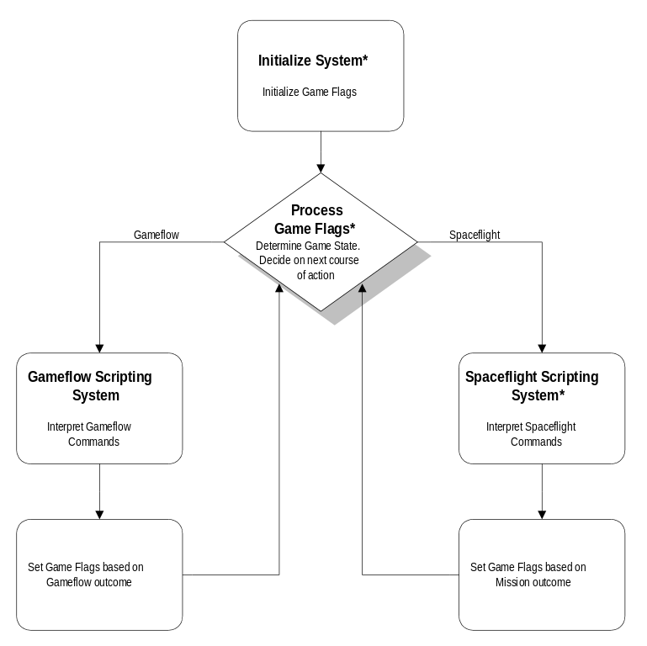
Figure 2 : Master Control Program (MCP) Overview

Spaceflight

Loading a Mission
Once the MCP decides that a spaceflight mission is to be run, the MCP sets up and loads a new program. This new program contains scripts to load objects required for the mission, as well as their mission programs. The engine is initialized, along with the AI scheduler.

The Spaceflight IOWin (Main Loop)
Once the mission starts, once per game loop, the AI scheduler will determine which objects to update that frame (see AI Scheduler). With this model, not every AI object has to be updated per frame. The objects are then set up to be updated with object::alter. Once all objects have been altered, the objects are updated with object::update and the world is rendered.

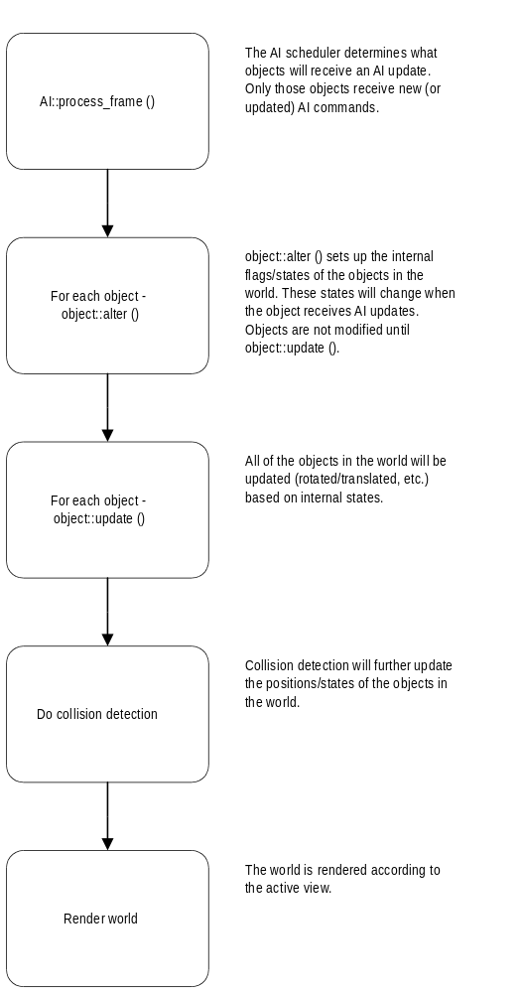
Figure 3 : Spaceflight IOWin (Main Loop)

Individual mission programs will set the appropriate Series (MCP, or GLOBAL) registers. The end of the mission is signaled either through mission commands from an object’s program, or the end of the global mission script. Control is then passed back to the MCP.

Gameflow
All data for Gameflow rooms will be created inside MED. The compiled data will be output as a ‘program’ which will be interpreted by the main MCP™ (Master Control Program). The ‘program’ is a list of commands and arguments that define the content and functionality of the room. The ‘program’ will create ‘objects’ that exist only within the room but will have access to all global game flags as well as its own local flags. Once the player leaves a room all objects are destroyed and that memory is freed up for the next room.

Each ‘object’ within the room will have properties assigned to it by the editor that will define its look and functionality. Default properties for each object type will coexist with user-defined properties. For example, all ‘Hot Spots’ will have x,y,w,h entries but may or may not have an ‘animation’ entry that would define an action that occurs when the cursor is placed over that hot spot.

The MCP™ will ‘step through’ the program data instruction by instruction only returning when all conditions have been met. Examples of conditions are ‘Talked to Maniac’ etc..

Once a program has been parsed and all relevant structs have been filled (See Structs below), control is passed back to the MCP™ until a recognized event takes place. The MCP™ will then scan for an active object (preferably the one that the player’s cursor is on top of) and. once found. check whether that object has a need for an action to take place based on the current event.

Transition System
Room ‘programs’ will have the ability to ‘jump’ to other programs or call ‘sub programs’ by passing control back to the MCP™ and giving it the name of the new program to run. The MCP™ will save the current IP (Instruction Pointer) of the calling program and run the new program as if it were a sub-routine. Once execution of the ‘sub program’ is completed the IP is reloaded from its saved position. This will enable player movement between rooms and menu systems/option screens. Care will be taken to avoid long periods of ‘blank’ screen that can detract from the player’s game immersion.

Game Save Console
Save/Load screens will be kept as simple as possible with little (or no) input required from the player. Operation should be quick in and out so as not to break up the player’s ‘game experience’. By displaying the Mission/Series information from each save game as a header no filenames will be necessary. (See Wing 3 3DO for an example)

User Options Console
Here the player will be able to adjust key game elements to his liking. Options will be categorized and grouped accordingly. Operation of the menu system should be quick and intuitive to not detract from the player game immersion.

Audio Options
Global Volume - Set using a slider control and affects both sounds effects and music.
Background Music Volume - Set using a slider control and affects only the music. This value will be used as a percentage setting of the overall global volume.
Effects Volume - Set using a slider control and affects only the sound effects. This value will be used as a percentage setting of the overall global volume.
Movie Volume - Set using a slider control and affects the playback level of the movies. This value will be used as a percentage setting of the overall global volume.

Controls
Default Key Layouts - Allows the player to choose from a predefined set of keyboard layouts
Key Layout - Allows the player to reassign key settings.
Joystick Layout - Allows players to redefine which events are generated by joystick operations.
Default Joystick Layouts - Allows the player to choose from a predefined set of layouts.
Mouse Sensitivity - Allows the player to set the reaction level of the game to mouse input.

Gameplay
Skill Level - Allows the player to set the level of gameplay ranging from ‘Rookie’ to ‘Holy Shit’
Collisions - Allows the player to be unaffected by collision with other objects.
Invulnerability - Allows the player to be immune to any enemy attack.
Unlimited Fuel - Allows the player’s ship to very fuel efficient!!
Unlimited Ammo - Allows the player to never run out of missiles etc.

Simulator
Standard Wing Commander simulator where the player can ‘practice’ his dogfight skills without severe repercussions.
Predefined ‘Simulator Only’ missions with increasing difficulty level (while the player remains alive!) will provide an ‘arcade’ feel.
NOTE: The Simulator may be dropped due to time constraints.

Medal And Kill Scoreboards
Standard Wing Commander style throughout. (Have make the player feel rewarded for his efforts!)
[Perhaps some interactivity between kill scores and players/computer attitude towards our hero? If Maniac leads the killboard he could become a little more annoyingly cocky than he already is?? Computer voice during debrief could remind player that “although he did very well, Mr. Maniac is still leading!”]

Debrief System

Data structures will include global flags that are set by the mission programs. These may include: PLAYER_KILLS, WINGMAN_KILLS, MISSION_SUCCESS, etc. that the debrief system will have access to when printing out the mission statistics.

An example of how a mission would be flown and finished:
- Launch. Instead of having a flick play to show fighters launching we will show the 3D Engine from a outside camera angle. View will be from outside the launch tube looking into it. We will script ship movement to fly through and out of tube & past camera. This will be extremely cool with dynamic lighting… maybe there is a spotlights or tubeway? (runway) lights that light ship as it comes out.
- Mission. PLAYER FLIES MISSION
- End of Mission- Player Confirms landing (automatically by default), engages the automatic landing sequence, then reads stats of his performance from a cockpit VDU (stats like weapon effectiveness, kills, friendlies killed, ship damage).
- The game takes control of the player’s ship, and we cut to an outside camera on the landing bay. We script the ship flying into the bay and it lands. Once again we are in the 3D Engine and all the damage from battle, etc.. should be shown on the fighter. Stats would be kept in medal place (Ready Room locker) in player’s flight log (this could used to describe an Autosaved game)...
- Movie - Player is then shown walking from landing bay with mechanic or other crew member saying “You might try flying your ship next time… or good job…”
- [OPTIONAL] Debriefing. Movie- Player is in debriefing and he is told how he did in the mission…says “ way to take out that ace pilot, now we have a chance at getting to that enemy carrier.” for plot specific debriefings.
- [OPTIONAL] Plot Specific Movies. Movie-player automatically runs any scenes that are critical to advancing the plot that take place outside of the main two room.

Memory Usage

CD
CD memory allocation is being estimated as follows:

ITEM MEGABYTES
Total CD Space: 680.00
Origin Catalog: 10.00
Game executable, etc: 1.75
Install executable, etc: 5.00
Full Screen Movies: 461.70
Inflight Comms: 40.00
Digital Music: 66.15
Digital Sound Effects: 10.00
Gameflow Data: 25.00
Spaceflight Data: 25.00
Language Files: 10.00
TOTAL REMAINING: 28.40

Total Minutes FMV: 45
Total Minutes Music: 25
All other values are estimates based on Wing IV.

System RAM
This section has yet to be written. However, care is being taken to not waste available memory. The minimum memory requirement for Wing Commander: Prophecy is 16 megabytes, twice as much memory as was needed to Wing IV. It is unlikely that the amount of available system RAM will be much of a problem. System RAM usage will be estimated in the near future.

Risk Assessment

Network Support Risks
This is by far, the biggest risk for Wing Commander: Prophecy. Jeff Grills is the only programmer involved with the project that has shipped a network game. The previous section regarding network support covers all the issues that are being examined.
Although a final decision has not been made regarding which method the project will follow, it is most probable that an asynchronous network model will be adopted. Although there are problems with keeping machines relatively synchronized, an asynchronous model has several advantages.

- It is easier to allow players to jump in and out of games at will.
- An asynchronous Client / Server setup opens up some possible financial opportunities for Origin.
- Asynchronous network models scale more easily to very high latency networks.

Windows 95 Risks

Direct X Support
One of the biggest risks with Windows 95 is Microsoft’s Direct X libraries. As of now, there do not seem to be any major problems with DirectDraw, or Direct 3D, but we still haven’t slotted in DirectSound. Reports seem to show that Direct X 3 has introduced problems with DirectSound. How are we supposed to handle the situation if the game is tested with one version of Direct X and is released, and then Microsoft releases new Direct X drivers that no longer work with our game?

Threads and Timing
One of the network models that has been considered for Wing Commander: Prophecy requires a real time thread running at around 60 Hz. Testing has shown that the Windows sleep command does not do an adequate job of timing, sometimes returning from sleep with a timing error of around 50%. Because of this lack of accurate thread timing, efforts are being focused on alternative network models.

Virtual Memory
This may not really be a problem, but it sounds a little scary. Windows likes to handle its RAM and disk space as a single pool of memory. In other words, something the game thinks is in RAM might actually be on disk, potentially slowing things down. Our current plan is to allocate a single block of memory (hopefully all RAM) at the start of the game, and handle all memory management from within the game. This might reduce the amount of dynamic allocations coming from disk. As for when and what Windows decides to swap to disk, it is unclear as to whether or not the game can have any control over it. It may not be wise to even try to keep game memory paged in RAM as it could cause problems with Windows 95’s multi-tasking environment.

Visual C++
Every once in a while, a bug with the Visual C++ compiler creeps up. This hasn’t caused any major problems so far, but it is something that the project must continue to watch out for. MemTracker, the game engine’s memory manager allocation tracking system, has recently helped us rapidly track down a compiler bug involving the deletion of templated objects.

AI Risks
At the start of the project, the AI system was designed very differently than the system used in Wing IV. The new system was to be based almost entirely on maneuvers that had been recorded while a designer flew the ship. This would have provided more natural looking maneuvers than code scripted ones.
However, after further assessment, it seemed as if this method would introduce some substantial risks, especially considering the new dynamics in Wing Commander: Prophecy. So, in response to this potential risk, the AI system has been reworked. In its current incarnation, the AI system can implement recorded maneuvers, maneuvers coded in C++ by programmers, as well as maneuvers coded in FLO code by the designers. This new system will be able to handle a Wing Commander game without many problems.

Audio Risks

Streaming
The major issue with streaming digital audio is being able to load data from the CD without causing the music to skip. A system to facilitate this was developed for Wing III 3DO, and worked quite well. The streaming system that will be implemented for Wing Commander: Prophecy will be based on that streamer.
For the most part, this really shouldn’t be too difficult of an issue, considering the fact that the game requires a quad speed CD-ROM drive at minimum. Wing III 3DO did fine with a double speed drive. The only real potential problem is streaming inflight comm video while playing digital music. Here are some possible solutions:

- Keep Comm messages short so enough digital music can be buffered to run while the comm is being played.
- Since Wing Commander: Prophecy requires 16 Megabytes of RAM (twice as much as Wing IV), it may be possible to pre-load small looping pieces of generic comm video or sprites, over which the appropriate audio track would be streamed. This would reduce the amount of data needed to stream while playing music.

Rendering Risks

Lighting
The actual process of lighting an object is not an issue. The problem has to do with detail levels. As an object gets further away from the camera, the object switches through a series of meshes, each mesh getting progressively simpler as the object moves away. As the level of detail within the mesh decreases, the geometry of the object begins to change. If two neighboring detail levels have a sufficiently different geometry, the lighting of the object will change drastically as one mesh is swapped out for another. This effect can be quite jarring. Below is a list of possible solutions.

- Depth haze polygons so that objects that are farther away look darker. This will probably reduce the “popping” effect when detail levels swap, but it will make objects look dim.
- Only use one moderate face count mesh for each object. This could simplify some things because it would free the artists from having to build several meshes for one object, as well as remove the need to choose which detail level mesh to render when drawing an object. The disadvantage is that a middle detail object will need to be chosen, resulting in a lower detailed object when it is close to the camera, and too many faces drawn when the object is far away.
- Make sure that the artists keep the geometry relatively similar between neighboring detail levels. This will not completely eliminate the “popping”, but it could reduce it. This coupled with allowing the artists to tweak vertex normals could significantly improve the appearance.

The third solution seems to be the best, and is the path that the project is currently following.

Capital Ships
Capital ships are painful to render because they fill a very large portion of the screen. Here are the optimizations that are currently underway in order to keep the frame rate up while close to a Capital Ship:

- Make sure artists generate relatively convex objects in order to reduce the amount of polygon occlusion.
- Artists texture map according to BSP splitting planes. This way, the game engine can draw an entire section of the Capital Ship before it has to swap texture maps, reducing texture thrashing. This is particularly important for hardware accelerators.
- We have a very fast software rasterizer.
- VSD research. Jeff Grills has already implemented a beam tree approach that is speeds up render time significantly in high overdraw situations, but does not scale well to low overdraw situations.

Object Sorting
The sorting of objects is accomplished by generating a BSP tree every frame to separate the objects. The current implementation works in most cases, but it is relatively easy to cause the BSP splitting algorithm to fail. Some ideas to fix this:

- Use cylinders as well as spheres.
- Generate convex hulls for objects and use a face from a convex hull in degenerate cases.
- When all else fails, drop a plane through an object, and render it as two separate halves. Currently, this case happens infrequently in Wing Commander: Prophecy.

Dynamically splitting objects with BSP planes could provide some very interesting effects. For example, a plane could be set for a jump gate, and objects passing through the gate would appear as if they are emerging from nowhere.

Native 3D Hardware Support
The greater the number of 3D accelerator cards we try to support, the less time we have to test them thoroughly. The current plan is to only provide “official” support for 3D hardware through Direct3D for the initial release of the product. This will greatly reduce coding and testing time. Support for various 3D accelerators can be written after the product has shipped, and customers can download the latest GLL from the Origin web site.

Monthly Programming Task Summaries

January 97
Task Programmer Status Duration
Collision Detection (first pass) ASOMMERS Complete 5 days
Collision Resolution (first pass) ASOMMERS Complete 5 days
Targeting ASOMMERS Complete 5 days
Targeting HUD Display (first pass) ASOMMERS Complete 5 days

Cockpit Data Format HDAVID Complete 5 days
Cockpit Primitive Element Lists HDAVID Complete 5 days
Language Manager (first pass) HDAVID Complete 5 days

AI Primitives JHUGHES Complete 10 days
Mission System AI Interface JHUGHES Complete 5 days
Configurable Pilot Profiles JHUGHES Complete 3 days

Configurable Ship Characteristics PSHELUS Complete 5 days
Shield System PSHELUS Complete 5 days
Shield HUD Display (first pass) PSHELUS Complete 1 day
Armor System PSHELUS Complete 5 days
Armor HUD Display (first pass) PSHELUS Complete 1 day

February 97
Task Programmer Status Duration
Audio Sample Management ASOMMERS In Progress 4 days
Asteroid Fields ASOMMERS In Progress 3 days
Auto Pilot (Action Spheres) ASOMMERS In Progress 4 days
Auto Pilot HUD Display ASOMMERS Complete 1 day
Mission Editor Multi-Player Support ASOMMERS Not Started 3 days
Message Plaques (first pass) ASOMMERS Complete 1 days
Briefing System Pre-implementation ASOMMERS Not Started 4 days

Main Menu (first pass) HDAVID In Progress 5 days
Multi-Player Screens (first pass) HDAVID In Progress 5 days
Call Sign Screen (first pass) HDAVID In Progress 4 days
Particle System HDAVID Complete 3 days
Explosions / Debris (first pass) HDAVID Complete 3 days

Communications System JHUGHES In Progress 10 days
Formation Flight Structures JHUGHES In Progress 5 days
Formation Flight JHUGHES In Progress 5 days

Gun Systems PSHELUS In Progress 5 days
Guns HUD Display (first pass) PSHELUS Complete 1 day
Missile Systems PSHELUS Not Started 5 days
Missile HUD Display (first pass) PSHELUS Not Started 1 day
Damage Systems PSHELUS In Progress 5 days
Damage HUD Display (first pass) PSHELUS Not Started 1 day
Turrets PSHELUS Not Started 2 days

March 97
Task Programmer Status Duration
Mission Statistics Tracking ASOMMERS Not Started 5 days
Scripted Briefing System ASOMMERS Not Started 7 days
Scripted Debriefing System ASOMMERS Not Started 7 days
Mission System / Editor Maintenance ASOMMERS Ongoing 5 days

Explosions / Debris (final pass) HDAVID Not Started 5 days
Game Options Screen (first pass) HDAVID Not Started 5 days
Language Manager (final pass) HDAVID Not Started 5 days

AI Maneuver Recording and Playback JHUGHES Not Started 10 days
AI Maneuver Selection JHUGHES Not Started 5 days
Multi-Ship Group AI Maneuvers JHUGHES Not Started 7 days

Configurable Missiles PSHELUS Not Started 2 days
Configurable Guns PSHELUS Not Started 2 days
Afterburner HUD Display PSHELUS Not Started 1 day
Collision Detection (second pass) PSHELUS Not Started 5 days
Collision Resolution (second pass) PSHELUS Not Started 5 days
Physics / Dynamics Tweaking PSHELUS Not Started 3 days
Turrets PSHELUS Not Started 2 days

April 97
Task Programmer Status Duration
Communications HUD (first pass) ASOMMERS Not Started 5 days
Navigational Map ASOMMERS Not Started 5 days
Mission System Multi-Player Support ASOMMERS Not Started 5 days
Mission System / Editor Maintenance ASOMMERS Ongoing 5 days

VCR Recording and Playback HDAVID Not Started 5 days
Shield Effects HDAVID Not Started 3 days
Jump Effects HDAVID Not Started 5 days

AI Maneuvers JHUGHES Not Started 10 days
AI Taunts JHUGHES Not Started 2 day
AI Death Communications JHUGHES Not Started 2 day
Capital Ship AI JHUGHES Not Started 5 days
AI Statistics Tracking JHUGHES Not Started 1 days

Power Ups PSHELUS Not Started 5 days
Power Distribution HUD (first pass) PSHELUS Not Started 5 days
Guns HUD Display (final pass) PSHELUS Not Started 3 days
Missile HUD Display (final pass) PSHELUS Not Started 3 days
Radar HUD Display PSHELUS Not Started 3 days

May 97
Task Programmer Status Duration
Save / Load / Auto Save ASOMMERS Not Started 5 days
Simulator (?) ASOMMERS Not Started 10 days
Gameflow Data Integration ASOMMERS Not Started 7 days
Mission System / Editor Maintenance ASOMMERS Ongoing 5 days

Sound Effects Data Integration HDAVID Not Started 5 days
Inflight Comms Data integration HDAVID Not Started 5 days
Medal Viewer HDAVID Not Started 5 days

AI Maneuvers JHUGHES Not Started 20 days

Countermeasures PSHELUS Not Started 3 days
Collision Detection (final pass) PSHELUS Not Started 5 days
Collision Resolution (final pass) PSHELUS Not Started 5 days
Repair HUD Display (first pass) PSHELUS Not Started 1 day
Damage HUD Display (final pass) PSHELUS Not Started 1 day
Power Distribution HUD (final pass) PSHELUS Not Started 3 days

June 97 (ALPHA June 5)
Task Programmer Status Duration
Message Plaques (final pass) ASOMMERS Not Started 2 days
Communications HUD (final pass) ASOMMERS Not Started 10 days
Targeting HUD Display (final pass) ASOMMERS Not Started 5 days
Mission System / Editor Maintenance ASOMMERS Ongoing 5 days

Object Viewer HDAVID Not Started 3 days
Music Data Integration HDAVID Not Started 5 days
Auto / Manual Take Off HDAVID Not Started 3 days
Auto / Manual Landings HDAVID Not Started 3 days

AI Tweaking JHUGHES Not Started 20 days

User Controlled Camera Views PSHELUS Not Started 3 days
Repair HUD Display (final pass) PSHELUS Not Started 1 day
Shield HUD Display (final pass) PSHELUS Not Started 1 day
Armor HUD Display (final pass) PSHELUS Not Started 1 day

July 97
Task Programmer Status Duration
Install Program ASOMMERS Not Started 10 days
Virtual Keyboard Editor ASOMMERS Not Started 10 days
Mission System / Editor Maintenance ASOMMERS Not Started 5 days

Main Menu (final pass) HDAVID Not Started 3 days
Call Sign Screen (final pass) HDAVID Not Started 3 days
Multi-Player Screens (final pass) HDAVID Not Started 5 days
Game Options Screen (final pass) HDAVID Not Started 5 days
Effects HDAVID Not Started 4 days

AI Tweaking JHUGHES Not Started 20 days

Bug Fixes and Polishing PSHELUS Not Started 20 days

August 97 (BETA August 28)
Task Programmer Status Duration
Miscellaneous Data Integration ALL Not Started 20 days

Movie Data Integration ASOMMERS Not Started 15 days
Mission System / Editor Maintenance ASOMMERS Ongoing 5 days

Demo FROAN Not Started 20 days

Effects HDAVID Not Started 15 days
Credits HDAVID Not Started 5 days

AI Tweaking JHUGHES Not Started 20 days

Bug Fixes and Polishing PSHELUS Not Started 20 days

September 97
Task Programmer Status Duration
Bug Fixes ALL Not Started 20 days

Demo FROAN Not Started 20 days

October 97 (FINAL October 23)
Task Programmer Status Duration
Bug Fixes ALL Not Started 20 days

November 97 (SIGN OFF November 6)
Task Programmer Status Duration
Bug Fixes ALL Not Started 4 days

Detailed Programming Task Summaries

The detailed task summaries have already been generated, but due to time restrictions were not able to be formatted in time to include with this version of the TDD. In reviewing the Monthly Task Summaries, it is only around June were some of the task lengths get a bit long regarding the AI. These tasks are actually broken down into finer tasks, and are basically implementing specific maneuvers. The full Detailed Programming Task Summaries will be included as soon as possible. As an example, a couple of February task summaries that the programmers use to gauge their progress each month are below…

January 97

February 97
Programmer: Peter Shelus
task name: Gun System
time scheduled: 5 days
time spent:
status: In progress

technical description (description of the task and what will be involved to complete it):
The current gun system implementation is not sufficient for the game design. Therefore, the system will be completely rewritten to allow the proper use of hard points, power ups, and gun selections.

checklist (what we'll see and how to determine task completion ):

- The player can toggle guns
- The player can select full guns
- Guns can be fired in an alternating pattern, or linked
- Guns will be properly placed on ship hard points
- Provisions for gun power ups will be implemented
- Guns will properly draw power from the gun pool
- Gun bolts will have damage information contained within them
- Individual guns can be damaged and destroyed

comments:

As far as I know, the above functionality will be sufficient for the game. However, I will be sure to talk with Billy prior to starting this task in order make sure that nothing is left out.
_____________________________________________________________________________________

Programmer: Peter Shelus
task name: Missile System
time scheduled: 5 days
time spent:
status: In progress

technical description (description of the task and what will be involved to complete it):
This system will be very similar to the Gun System. Missiles will allow proper use of hard points, power ups, and gun selections. Damage information will be implemented in such a way that the designers can easily edit missile properties.

checklist (what we'll see and how to determine task completion ):

- The player can toggle missile types
- Missiles can be fired
- Missiles will be properly placed in ship hard points
- Provisions for missile power ups and reloading will be implemented
- Missiles will be attached to the power plant, to allow for leeched ships
- Missiles will have damage information contained within them
- Individual missiles can be damaged and destroyed

comments:
As was said above, missiles should be very similar to guns.
_____________________________________________________________________________________

Programmer: Peter Shelus
task name: Configurable missiles and guns
time scheduled: 5 days
time spent:
status: In progress

technical description (description of the task and what will be involved to complete it):
Data file formats will be set up to allow the designers to configure the missiles and gun bolts. Designers will be able to enter damage information and velocities for both bolts and missiles. Missiles will have separate fields for impact / warhead damage, as well as the type of damage the missiles impart.

checklist (what we'll see and how to determine task completion ):

- Designers can set damage and velocity information for bolts
- Designers can set damage and velocity information for missiles
- Data files are loaded in the game weapon properties are working

comments:
This will also involve some thought on how to minimize load times. Loading large numbers of files is bad, especially from CD (250 msec seek time… OUCH!)
_____________________________________________________________________________________

Programmer: Peter Shelus
task name: Gun HUD (first pass)
time scheduled: 1 day
time spent:
status: In progress (Concurrent with Gun System task)

technical description (description of the task and what will be involved to complete it):
This will be a first pass, simple Heads Up Display for the Gun System. It will display the currently selected gun type, full guns status, as well as a gun pool.

checklist (what we'll see and how to determine task completion ):

- Displays selected gun type
- Displays full guns status
- Displays working gun pool

comments:
This is pretty easy.
_____________________________________________________________________________________

Programmer: Peter Shelus
task name: Missile HUD (first pass)
time scheduled: 1 day
time spent:
status: In progress (Concurrent with Missile System task)

technical description (description of the task and what will be involved to complete it):
This will be a first pass, simple Heads Up Display for the Missile System. It will display the currently selected missile type, and the number of missiles of that type remaining.

checklist (what we'll see and how to determine task completion ):

- Displays selected missile type
- Displays number of missiles of that type remaining

comments:
Also pretty easy
_____________________________________________________________________________________

Programmer: Peter Shelus
task name: Damage / Repair System
time scheduled: 5 days
time spent:
status: In progress

technical description (description of the task and what will be involved to complete it):
The Damage / Repair system is was keeps track of the ship’s total damage and attempts to repair it. This system will maintain a list of all ship components and the damage levels associated with each component. This list will be prioritized and the repairs will begin on the most important systems.

checklist (what we'll see and how to determine task completion ):

- Repair system generates and maintains a list of all ship components
- List is prioritized
- Repairs are carried out
- Repair system is properly hooked up to power system
- Damage to the repair system reduces the repair efficiency

comments:
Check with Billy about the prioritization schedule, and how the repairs should be carried out.
_____________________________________________________________________________________

Programmer: Peter Shelus
task name: Damage / Repair HUD (first pass)
time scheduled: 1 day (Concurrent with Damage / Repair System task)
time spent:
status: In progress

technical description (description of the task and what will be involved to complete it):
This will be a first pass display to show the player the current damage level of each ship component, and the current repair.

checklist (what we'll see and how to determine task completion ):

- Displays list of ship components and their damage levels
- Display will be prioritized by repair importance
- The current repair will be at the top of the list

comments:
Once again, pretty straight forward.
_____________________________________________________________________________________

Programmer: Andy Sommers
task name: Audio sample management
time scheduled: 4 days
time spent:
status: In progress

technical description (description of the task and what will be involved to complete it):
A system needs to be written and integrated into the mission loading process that will serve as a container to hold all of the game sound effect samples. Additionally, it should be easy for the designers to add new sound events without needing to recompile the game.

checklist (what we'll see and how to determine task completion ):

- Sound event system needs to be designed
- Sample manager should load from a data file the events and sounds associated with those events
- Data files should (can) be unique per mission
- Designers should be able to add/remove/replace sound effects easily
- Sample format should correspond to the sound system sample format

comments:
In order to finish the sample manager, the sound system needs to be integrated into the game. The sound system will provide information as to what types of sound data needs to be stored with each sample and the format.
_____________________________________________________________________________________

Programmer: Andy Sommers
task name: Asteroid fields
time scheduled: 5 days
time spent:
status: In progress

technical description (description of the task and what will be involved to complete it):
Asteroid fields represent obstacles for the player to avoid in spaceflight. A system needs to be written to allow the creation of “natural-looking” asteroid fields in spaceflight.

checklist (what we'll see and how to determine task completion ):

- Asteroid fields can be placed in MED missions
- Asteroid fields should be configurable
- number of asteroids
- number of control points
- control point radius
- random yaw/pitch/roll rates
- Asteroids should be checked for collisions
- Asteroid fields should look natural (use splines instead of lines)

comments:
Need more asteroid art. I currently have only one asteroid object.
_____________________________________________________________________________________

Programmer: Andy Sommers
task name: Autopilot (action spheres)
time scheduled: 5 days
time spent:
status: In progress

technical description (description of the task and what will be involved to complete it):
The autopilot system depends on the action sphere system.

checklist (what we'll see and how to determine task completion ):

- Designers can place nav points (action spheres) in MED missions
- Designers can traverse between nav points in spaceflight
- Objects can be placed in any desired list in any desired action sphere

comments:
Time should be taken to attempt to minimize the number of objects receiving updates/collision-checks/renders.
_____________________________________________________________________________________

Programmer: Andy Sommers
task name: Autopilot HUD display
time scheduled: 1 day
time spent:
status: Have not started

technical description (description of the task and what will be involved to complete it):
This will be a first pass, simple Heads Up Display for the Autopilot System. It will display whether or not the ability to autopilot to the next action sphere is possible.

checklist (what we'll see and how to determine task completion ):

- Need to determine if autopilot is possible (enemies in action sphere)
- Displays AUTO when autopilot is possible
- Displays nothing when autopilot is not possible

comments:
This is pretty easy.
_____________________________________________________________________________________

Programmer: Andy Sommers
task name: Message Plaque System
time scheduled: 2 days
time spent:
status: Have not started

technical description (description of the task and what will be involved to complete it):
This will be a first pass, simple Message Plaque system to display inflight text messages/comms.

checklist (what we'll see and how to determine task completion ):

- Message system queue’s messages
- Message system displays message for specified time, and moves onto next message (with scrolling)

comments:
_____________________________________________________________________________________

Programmer: Andy Sommers
task name: Continued mission editor work
time scheduled: 5 days
time spent:
status: Ongoing

technical description (description of the task and what will be involved to complete it):
Adding new features and new commands to the editor.

checklist (what we'll see and how to determine task completion ):

- Integrate asteroid fields
- Integrate action spheres
- Integrate ability to send comm messages
- Add new commands/fix bugs as needed
__________________________________

Programmer: Andy Sommers
task name: Multi-player mission system support
time scheduled: 3 days
time spent:
status: Have not started

technical description (description of the task and what will be involved to complete it):
Setup ability for designers to place multiple players in the world

checklist (what we'll see and how to determine task completion ):

- MED can place players and the players are started in the desired positions

comments:
In order to test this properly, I will need multi-player support in the game.

March 97

April 97

May 97

June 97

July 97

August 97

September 97

October 97

November 97

Appendix A – Scripting Language Specification
FLAGS/VARIABLES

- A flag or variable is simply a named piece of data with an initial value.
- A flag will belong to a variable list.
- A flag name can be a free form any-length string.
- The flag name must be unique to its variable list.
- The variable list will belong to a game data file. (ex. Series or Mission file)
- The game can have a hierarchy of variable lists, forming individual scopes.
- The “series” variable list can be thought of as global flags.
- The “mission” variable lists can be thought of as local flags.
- Flag names are converted internally into unique 32-bit code via a CRC function.
- Flag types limited to simple types (i.e. int, float) or enum’s defined by the user.

Scope… programs can use local and global variables. For the interpreter to resolve a variable reference it should be able to search the Mission variables for a match and if not found search the Series variables.

It is recommended that the game interpreter pre-scan the program to convert variable CRCs into actual variable pointer, to avoid searching at run-time.

COMMANDS

All commands are internally represented as simple op-codes and parameters.

The output format for a single command is:

int32 id; // CRC of command name
int32 size; // 0..n rounded to 4-byte boundaries
char args[size];

There is a list of predefined system commands to facilitate C-like operations.

_Assign(dst,value) dst = value

_Add(dst,src,value) dst = src + value
_Sub(dst,src,value) dst = src - value

_Mul(dst,src,value) dst = src * value
_Div(dst,src,value) dst = src / value

_And(dst,src,value) dst = src & value
_Or(dst,src,value) dst = src | value
_Xor(dst,src,value) dst = src ^ value

_Label(num) @1
_Goto(num) goto @1

_Compare(src,cmp_type,value) if (src CMP value)
_BeginBlock {
_EndBlock }
_Else else

The user can define custom commands through a configuration header file.

extern void SetPilot (enum Roster pilot);

This should be the main way of implementing game specific operations.

Name Mangling

All system commands names should be prefixed with a ‘_’ character.
Multiple types are supported in system commands via name mangling.

Compiler deciphers types for system commands from user context.

USER ENTERS… COMPILES TO…
flag = int _Assign_Fi
flag = float _Assign_Ff
flag1 = flag2 _Assign_FF

Math Operations

Although commands are limited

VALID ENTERIES… COMPILES TO..
flag += value _Add_FFi(flag,flag,value)
flag = flag + value _Add_FFi(flag,flag,value)

INVALID ENTRIES
flag = flag1 + flag2 + 0 must simplify expression
flag = 4 + flag no parameter juggling YET
flag = 4 - flag no reverse subtract YET

CONDITIONAL OPERATIONS

VALID ENTERIES… COMPILES TO..
if (flag < 5) _Compare_Fii(flag,’<’,5)

Note: ‘<’ is symbolic… there is an enumerated type that defines the compare types

enum CompareType
{
CMP_Equal,
CMP_NotEqual,
CMP_LessThan,
CMP_LessThanEqual,
CMP_MoreThan,
CMP_MoreThanEqual,
};

LABELS

the current notation for at label is “@#”
@1 is a valid label
to use character strings instead of numbers would be a significant task
CRC’ing the name would require the ability to decompile it to a string

the “goto” command is used to move execution to a new location

@5 _Label(5)
if (flag == 0) _Compare(flag,’=’,0);
goto @5 _Goto(5)

currently the interpreter must search the program for labels…

It should be possible for the editor or the game to pre-scan the programs
and fixup label values into relative addresses (not YET)

RETURN VALUES

flag = GetPilot(ship_type);

Example Program:

// sample program script (test.wc)
{
// Init counter
i = 0;

// Label @1
@1

ActivateObject(7);
i += 1;
if (i < 10)
{
goto @1
}
}

Appendix B – Mission Editor
MED Sector

The Sector file defines the static appearance and default behavior for a continuous region of space (note: a jump point is a discontinuity in space) This definition can include the layout of stars/planets for the background, the placement of asteroid fields, placement of space stations and jump points, random encounter probabilities and any other constant data that pertains to a region of space.

With MED, the designers can create a Sector template that will consist of the stars, planets, heavenly bodies, ambient light levels, other lighting levels (point and directional lights), bases, etc. This sector template can then be loaded and modified for a single mission (friendly and enemy ships created, etc.) This would keep continuity between missions that happen in the same region of space in the game.

Since a Mission File has the ability to supplement any and all Sector data, it is advisable to NOT keep story/scenario specific information in the sector data. (Ex. You might want to use a collection of constant sector files for an on-line persistent world where the whole universe could change from month to month. The only new files a user would need would be Mission Files.)

The separation of Sector and Mission data may seem strange for the basic Wing Commander scenario, but the added flexibility is important for a game like Privateer in which regions of space are commonly re-used.

The Sector file format is an IFF format data file whose outermost form name is “SECT”. This form is simple a wrapper for a LibTools-standard property list file. Sequential chunks of user-definable data specific to sectors.

This Sector file below is depicted below in MIFF format for textual clarity. Editing and construction will be performed with an editor with a complete visual interface. Output of the editor will be the file used by the game. A sample of the interface follows.

Example Sector file : “sectorK9.sct”

FORM “SECT”
{
CHUNK “NAME”
{
“Gamma Quad”
}

FORM “PROP” // object property list
{
FORM “OBJ”
{
CHUNK “BASE”
{
x,y,z
frame
OBJTYPE_JUMP
}
CHUNK “APPR”
{
“stargate”
}
CHUNK “JUMP”
{
“Gamma 1” // this point name
“sector-z1” // destination sector
“Zeta 2” // destination gate
}
CHUNK “NEAR”
{
FILTER_OBJECTS
100m
“lightning” // when object is within 100m
// animate lightning
}
}

FORM “OBJ”
{
CHUNK “BASE”
{
x,y,z
frame
OBJTYPE_SHIP
}
CHUNK “APPR”
{
“dralthi”
}
}

FORM “OBJ”
{
CHUNK “BASE”
{
x,y,z
frame
OBJTYPE_AREA
}
FORM “FILL” // a random field of objects
{
CHUNK “SPHR” // what is the shape of the asteroid field
{
250 km radius
}
CHUNK “DENS” // what is the density for filling the
// field with objects
{
0.05 objects per cubic-meter
}
CHUNK “PROB” // probability of placing object
{
50%, “asteroid0”
}
CHUNK “PROB” // probability of placing object
{
25%, “asteroid1”
}
CHUNK “PROB” // probability of placing object
{
25%, “asteroid2”
}
}
FORM “OBJ”
{
// this child object would be relative to the asteroid field
}
}

} // PROP
}

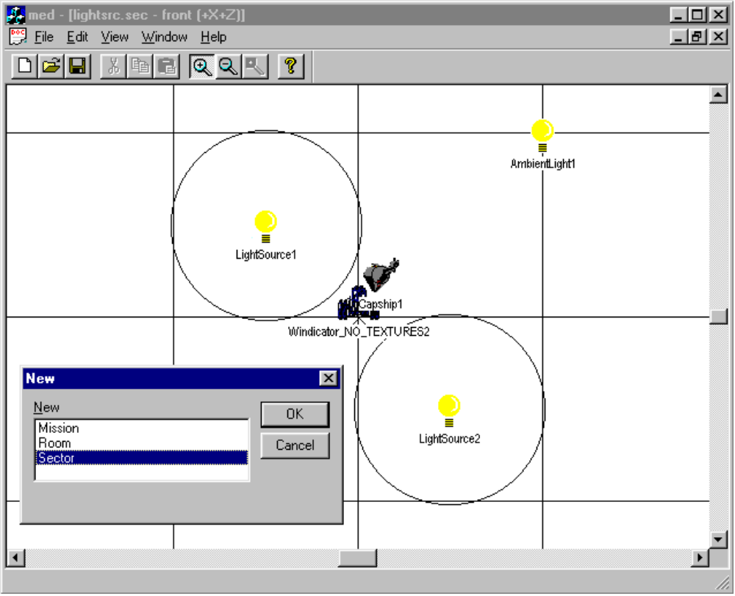
Figure 4 : MED Screen Shot - Creating a "Sector"

Creating a sector is simply choosing an object from a list of objects and positioning them in 3D space represented by a 2D grid.

The designer can put any object available in the game on the map window, while having the ability to change the object’s attributes (AI skill level, heading, direction, timing information., etc.) at any time. Also included is the ability to insert, wherever necessary, mission-specific sounds and communications messages.

Here you can see where you see the mission map’s <X,Z> layout. X and Z are laid out horizontally and vertically. There are buttons to zoom in and out. The editor tries to use as much of the Windows 95 interface as possible. For example : right-clicking on an object brings up a properties dialogue, allowing the user to change its values. Left-clicking and dragging, will reposition the object. Holding the Ctrl-key while dragging the object will copy the object, and holding the Shift-key while dragging the object, will snap the object to an grid line to allow perfect and uniform placement.

MED Room

The Room file defines static point-and-click surfaces. These include hot spots, sprites, animations, music, etc.

The Gameflow file is an IFF format data file whose outermost form name is “FLOW”. This form is simply a wrapper for a LibTools-standard property list. The contents are a sequential tree list of user-definable data blocks.

The Room file below is depicted below in MIFF format for textual clarity. Editing and construction will be performed with an editor with a complete visual interface. Output of the editor will be the file used by the game. A sample of the interface follows.

FORM “FLOW”
{
CHUNK “NAME”
{
“Tiger’s Claw”
}

FORM “HOTS” // example
{
CHUNK “NGON”
{
x,y, x,y, x,y, x,y
}

CHUNK “SPRT”
{
“data\hobbes.spr”
}

CHUNK “OVER” // ie. OnMouseOver()
{
ANIM, +
TEXT, IDT_GO_TO_BARRACKS
}

CHUNK “LCLK” // ie. OnLBtnClick()
{
DOOR = “room2.flo”
}
}

FORM “PROP” // object property list
{
// hot spots, sprites, animations, conversations, etc.
…
}
}

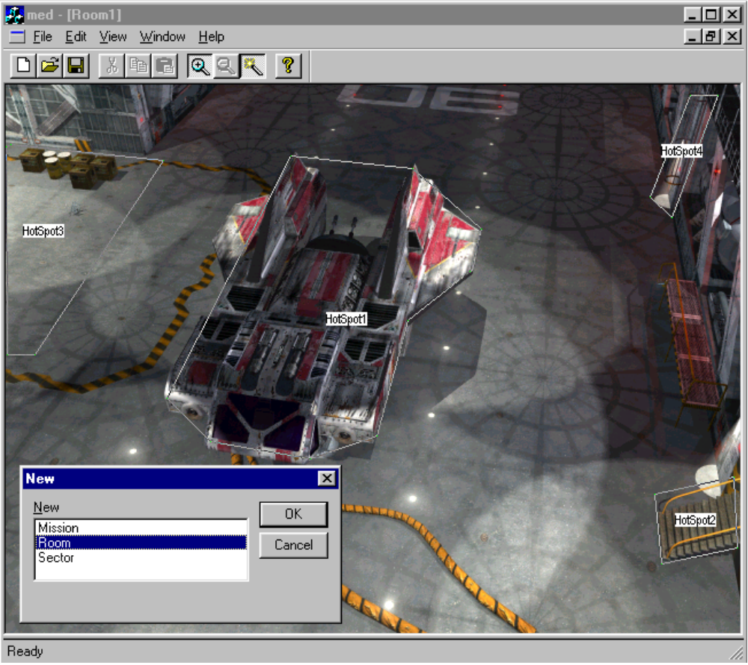
Figure 5 : MED Screen Shot - Creating a "Room"

Creating a room is accomplished by selecting the Gameflow background, and defining “hot spots” that perform actions when clicked.

MED Mission

The Mission file defines temporary scenario changes for all elements of the game environment. This definition will include new objects and behaviors for sectors, new hot spots and conversations for Gameflow rooms and any other data modifications the current state of the story needs to affect.

Essentially the mission data is a list of modifications to make to the normally static regions the player passes through. The game engine should allow multiple missions to be active. When the game requests static data for a location it should also ask the active Mission(s) for any extra information about a location.
For example: a single Mission File “test.msn” could contain a list of objects for “sectorB1.sct” (ie. ships, navpoints, programs) and a list of objects for “sectorZ2.sct” and a list of objects for “tigrclaw.flo” (ie. hot spots, sprites, animations, doorways, conversations). When the player enters “sectorB1” it would load the static data from the Sector File and then add objects from “test.msn” to the active scenario. If the player were then to land on the Tiger’s Claw the game would load the static data from the Gameflow File and then add objects from “test.msn” to modify the rooms.

The Mission File is an IFF format data file whose outermost form name is “MISN”. This form is simply a wrapper for a LibTools-standard property list. The contents are a sequential tree list of user-definable data blocks.

The Room file below is depicted below in MIFF format for textual clarity. Editing and construction will be performed with an editor with a complete visual interface. Output of the editor will be the file used by the game. A sample of the interface follows.

FORM “MISN”
{
CHUNK “FLAG” // local flags with default values
{
dword 0,0,0,0,0,0,0,0
}

FORM “MODS” // modifications for SECTOR file
{
CHUNK “FILE”
{
string “data\sectors\sector-j1.sct”
}
FORM “PROP” // property list of objects to add to sector
{
// programs, nav points, jump gates, objects
…
}
}

FORM “MODS” // another SECTOR that the mission affects
{
CHUNK “FILE”
{
string “smdata\sector\sector-j1.sct”
// Note: example of a “Secret Missions” disk scenario filename
}
FORM “PROP”
{
…
}
}

FORM “MODS”
{
CHUNK “FILE”
{
string “data\gameflow\tigerclw.flo”
}
FORM “PROP” // object list
{
// programs, nav points, jump gates, objects
…
}
}
}

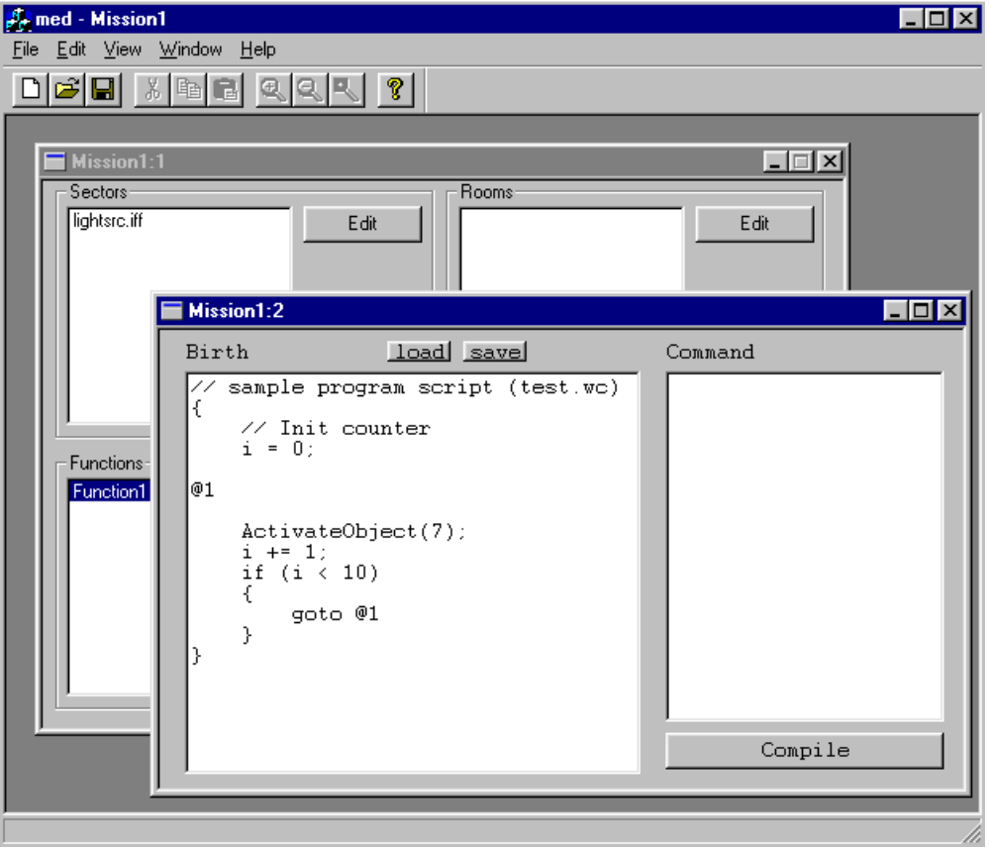
Figure 6 : MED Screen Shot - Creating a "Mission"

Missions are composed of Sectors and Rooms. The designers can associate functions (or Programs) with the Sector objects and the Room hot spots. These Programs use the FLO scripting language.

MED Series

The Series file is to define the presentation and connection of missions as dictated by the story. This includes a list of global flags and their default values and a collection of FLO scripts that activate missions, launch movies, modify flags and anything else that serves to sequence the player through the game story.

The Series file is the root file for a game scenario. All other data files are referenced through the contents of the series data. Global variables (GAME FLAGS) will receive their own window. It displays a list of pertinent variables (how many ships are dead, whether the base was destroyed). New variables can be placed, default values to be assigned, and variable properties and types can be updated.

For Example: a series file “WC5.SRS” might contain a BIRTH program that plays an intro movie, activates missions A1 and A2 and places the player in Starbase X Room 4. The UPDATE program might wait for A1 and A2 to be completed before playing a travel movie and activating mission B1. The DEATH program for the series would play a win/lose movie and scroll the credits finally dumping back to the title sequence.

The Series File is an IFF format data file whose outermost form name is “SERS”. This form is simply a wrapper for a LibTools-standard property list. The contents are a sequential tree list of user-definable data blocks.

The Series file below is depicted below in MIFF format for textual clarity. Editing and construction will be performed with an editor with a complete visual interface. The Series file will be a FLO program that will also be compiled by MED. Output of the editor will be the file used by the game.

FORM “SERS”
{
FORM PATH
{
CHUNK MISN
{
string “data\missions\%s.msn” // sprintf(id) format string
}

CHUNK SECT
{
string “data\sectors\%s.sct” // sprintf(id) format string
}

CHUNK FLOW
{
string “data\gameflow\%s.flo” // sprintf(id) format string
}
}

CHUNK “FLAG” // global flags
{
0,100,2,17,0,0,0,0,0,1,0,0,0,0
}

CHUNK “BEGN” // birth program
{
PlayMovie “Intro”
ActivateEvent “A-series”
GameFlow “TigersClaw”,1
}

CHUNK “UPDT” // update program
// Actual program will be a compiled
// script from MED
{
if (Global_Sword_Found)
ActivateMission “misn-x”

if (Global_Lose_Game)
PlayMovie “TheEnd”
Jump “Title”
}

FORM “EVNT”
{
CHUNK “NAME”
{
EVENT_INACTIVE
string “A-series”
}

CHUNK “BEGN”
{
ActivateMission “misn-a1”
ActivateMission “misn-a2”
ActivateMission “misn-a3”
}

CHUNK “UPDT”
{
if (Global_a2_complete)
DeactivateEvent “A-series”
ActivateEvent “B-series”
}

CHUNK “END”
{
DeactivateMission “misn-1”
DeactivateMission “misn-2”
DeactivateMission “misn-3”
}
}

FORM “EVNT”
{
CHUNK “NAME”
{
EVENT_INACTIVE
string “B-series”
}
…
}

FORM “MISN”
{
CHUNK “FILE”
{
string “misn-a1”
}

CHUNK “FLAG”
{
0,0,0,0
}

FORM “SECT”
{
CHUNK “NAME”
{
“Gamma Quad”
}

FORM “OBJS”
{
…
}
}
CHUNK “LINK”
{
if (OnComplete)
Deactivate “misn-a1”
Activate “misn-b2”
}
}
}

Sample MED Configuration Files

The mission system programmer will configure the editor for the designers. Sample configuration files will prototype actual script program functions to be used in the game. This will allow the MED editor to expand functionality without recompilation of the editor, and will allow the editor to be used to any type of game.

The following file is provided as a sample for tailoring the game to a Wing Commander. The user commands section is where the definitions and function prototypes are placed.

PROGCMDS.CFG

//
// COMMANDS and PARAMETERS for PROGRAMS
//

//-------------------------------------------------------------------
// SYSTEM COMMANDS - Do Not Modify!
//-------------------------------------------------------------------

typedef int FlagId;
typedef int ObjectId;

// Flow of Control

extern void _Label (int label_num); // @123
extern void _Goto (int label_num); // goto @123;
extern void _Call (int crc_routine);
extern void _End (void); // aka: return from
// sub-routine
extern void _Fatal (int err);
extern void _Blank (void); // purely for making script
// code look nicer

extern void _BeginBlock (void); // "{"
extern void _EndBlock (void); // "}"
extern void _Else (void); // "else"

// Assignment - compiler generated commands

extern void _Assign_Fi (FlagId f, int value); // "flag = 1"
extern void _Assign_Ff (FlagId f, float value); // "flag = 3.1415"
extern void _Assign_FF (FlagId f, FlagId v); // "flag = tmp"

// Comparison - compiler generated commands

enum CompareType
{
CMP_Equal,
CMP_NotEqual,
CMP_LessThan,
CMP_LessThanEqual,
CMP_MoreThan,
CMP_MoreThanEqual,
};

extern int _Compare_Fii (FlagId f, CompareType cmp, int value); // "if (f == 1)"
extern int _Compare_Fif (FlagId f, CompareType cmp, float v); // "if (f >= 3.1415)"
extern int _Compare_FiF (FlagId f, CompareType cmp, FlagId v); // "if (f < tmp)"

// Math - compiler generated commands

extern void _Add_FFi (FlagId dst, FlagId src, int value); // "dst = src + 1"
extern void _Add_FFf (FlagId dst, FlagId src, float value); // "dst = src + 3.1415"
extern void _Add_FFF (FlagId dst, FlagId src, FlagId v); // "dst = src + tmp"

extern void _Sub_FFi (FlagId dst, FlagId src, int value); // "dst = src - 1"
extern void _Sub_FFf (FlagId dst, FlagId src, float value); // "dst = src - 3.1415"
extern void _Sub_FFF (FlagId dst, FlagId src, FlagId v); // "dst = src - tmp"

extern void _Mul_FFi (FlagId dst, FlagId src, int value); // "dst = src * 1"
extern void _Mul_FFf (FlagId dst, FlagId src, float value); // "dst = src * 3.1415"
extern void _Mul_FFF (FlagId dst, FlagId src, FlagId v); // "dst = src * tmp"

extern void _Div_FFi (FlagId dst, FlagId src, int value); // "dst = src / 1"
extern void _Div_FFf (FlagId dst, FlagId src, float value); // "dst = src / 3.1415"
extern void _Div_FFF (FlagId dst, FlagId src, FlagId v); // "dst = src / tmp"

//-------------------------------------------------------------------
// USER COMMANDS (game specific)
//-------------------------------------------------------------------

typedef unsigned char byte;
typedef unsigned short word;
typedef unsigned long dword;

enum PilotNames
{
CactusJack,
LongTallSally,
WildEyedJack,
DickTracy,
SuperDad
};

enum ShipTypes
{
Dralthi=1,
Ralari,
TigersClaw=5,
Subaru,
Vindicator=10,
Excalibur,
X_Wing,
TieFighter
};

typedef int IntelLevel; // RANGE(0,100)
typedef float PatrolRadius; // RANGE(0,100000)
typedef float Range; // RANGE(0,999999)

extern void Test (byte b, short s, dword d);

extern void SetShipType (ShipTypes ship);
extern void SetWingman (ObjectId w);
extern void SetPilot (PilotNames p);
extern void SetIntelligence (IntelLevel i);
extern void SetPatrolRadius (PatrolRadius r);
extern void Explode (void);
extern void SetTarget (ObjectId t);

extern void ActivateObject (ObjectId id);
extern void DeActivateObject (ObjectId id);

extern Range GetDistance (ObjectId o1, ObjectId o2);

extern void StopMission (void); //int value=0);
extern void ExitMission (int success);

MED will use the input configuration files to create header files that should be included with the game. The FLO compiler will CRC or “tokenize” the functions and types so that the output data stream can be interpreted in the game.

A sample output header file to be included with the game is listed below. The function names of the input file are tokenized (and preceded with CMD_) and structures describing the arguments are created (and preceded with ARGS_).

//---------------------------------------------------------------------------
/*
PROGCMDS_H

Wing # (c)1996 ORIGIN

10-09-96 auto-created (pci@libtools)
*/
//---------------------------------------------------------------------------

#ifndef PROGCMDS_H
#define PROGCMDS_H

//---------------------------------------------------------------------------
// CMD defintions
//---------------------------------------------------------------------------

#define CMD__Label 0xF49C32D3
struct ARGS__Label
{
int label_num;
};

#define CMD__Goto 0x695574B8
struct ARGS__Goto
{
int label_num;
};

#define CMD__Call 0xF7BB0706
struct ARGS__Call
{
int crc_routine;
};

#define CMD__End 0x549EB3B7

#define CMD__Fatal 0xC2EB30B4
struct ARGS__Fatal
{
int err;
};

#define CMD__Blank 0xC610A65E

#define CMD__BeginBlock 0x15FBBB11

#define CMD__EndBlock 0x008277E1

#define CMD__Else 0x6E8E7DB3

#define CMD__Assign_Fi 0x5414BB49
struct ARGS__Assign_Fi
{
FlagId f;
int value;
};

#define CMD__Assign_Ff 0xC4ABA6D8
struct ARGS__Assign_Ff
{
FlagId f;
float value;
};

#define CMD__Assign_FF 0xFFC58610
struct ARGS__Assign_FF
{
FlagId f;
FlagId v;
};

#define CMD__Compare_Fii 0x7D04E63F
struct ARGS__Compare_Fii
{
FlagId f;
enum CompareType cmp;
int value;
};

#define CMD__Compare_Fif 0xEDBBFBAE
struct ARGS__Compare_Fif
{
FlagId f;
enum CompareType cmp;
float v;
};

#define CMD__Compare_FiF 0xD6D5DB66
struct ARGS__Compare_FiF
{
FlagId f;
enum CompareType cmp;
FlagId v;
};

#define CMD__Add_FFi 0xE499DC9F
struct ARGS__Add_FFi
{
FlagId dst;
FlagId src;
int value;
};

#define CMD__Add_FFf 0x7426C10E
struct ARGS__Add_FFf
{
FlagId dst;
FlagId src;
float value;
};

#define CMD__Add_FFF 0x4F48E1C6
struct ARGS__Add_FFF
{
FlagId dst;
FlagId src;
FlagId v;
};

#define CMD__Sub_FFi 0x531275E6
struct ARGS__Sub_FFi
{
FlagId dst;
FlagId src;
int value;
};

#define CMD__Sub_FFf 0xC3AD6877
struct ARGS__Sub_FFf
{
FlagId dst;
FlagId src;
float value;
};

#define CMD__Sub_FFF 0xF8C348BF
struct ARGS__Sub_FFF
{
FlagId dst;
FlagId src;
FlagId v;
};

#define CMD__Mul_FFi 0xDBC32C14
struct ARGS__Mul_FFi
{
FlagId dst;
FlagId src;
int value;
};

#define CMD__Mul_FFf 0x4B7C3185
struct ARGS__Mul_FFf
{
FlagId dst;
FlagId src;
float value;
};

#define CMD__Mul_FFF 0x7012114D
struct ARGS__Mul_FFF
{
FlagId dst;
FlagId src;
FlagId v;
};

#define CMD__Div_FFi 0x101F2404
struct ARGS__Div_FFi
{
FlagId dst;
FlagId src;
int value;
};

#define CMD__Div_FFf 0x80A03995
struct ARGS__Div_FFf
{
FlagId dst;
FlagId src;
float value;
};

#define CMD__Div_FFF 0xBBCE195D
struct ARGS__Div_FFF
{
FlagId dst;
FlagId src;
FlagId v;
};

#define CMD_Test 0x59090E2E
struct ARGS_Test
{
byte b;
short s;
dword d;
};

#define CMD_SetShipType 0xC3AC8939
struct ARGS_SetShipType
{
enum ShipTypes ship;
};

#define CMD_SetWingman 0xB354A73D
struct ARGS_SetWingman
{
ObjectId w;
};

#define CMD_SetPilot 0x18695FFB
struct ARGS_SetPilot
{
enum PilotNames p;
};

#define CMD_SetIntelligence 0x59EB8249
struct ARGS_SetIntelligence
{
IntelLevel i;
};

#define CMD_SetPatrolRadius 0xA9CEFA11
struct ARGS_SetPatrolRadius
{
PatrolRadius r;
};

#define CMD_Explode 0x06A2CA6F

#define CMD_SetTarget 0x3BF2AC3D
struct ARGS_SetTarget
{
ObjectId t;
};

#define CMD_ActivateObject 0x3C422148
struct ARGS_ActivateObject
{
ObjectId id;
};

#define CMD_DeActivateObject 0xB7B4605D
struct ARGS_DeActivateObject
{
ObjectId id;
};

#define CMD_GetDistance 0xE534763F
struct ARGS_GetDistance
{
ObjectId o1;
ObjectId o2;
};

#define CMD_StopMission 0xF3C255FC

#define CMD_ExitMission 0x58EDCC8A
struct ARGS_ExitMission
{
int success;
};

//---------------------------------------------------------------------------

#endif // PROGCMDS_H

Program Scripting Design (Script Commands)

Flags
SetLocalFlag(Flagname)
IncrementLocalFlag(Flagname) // ++
DecrementLocalFlag(Flagname) // --
ClearLocalFlag(Flagname

SetGlobalFlag(Flagname)
IncrementGlobalFlag(Flagname)
DecrementGlobalFlag(Flagname)
ClearGlobalFlag(Flagname)

Object
Attack(TargetObject) and Attack(TargetObject, WithinRange)
MustAttack(TargetObject) //Ignore all other enemies
PriorityAttack(TargetObject1, TargetObject2, TargetObject3)
Defend(TargetObject or Location) and Defend(TargetObject or Location, WithinRange)
PriorityDefend(TargetObject1, TargetObject2, TargetObject3)
Ignore(EnemyType) and Ignore(Target1, Target2, etc.)
Harass(TargetObject, Location) //Attack, then lure to location
Evade(EnemyType) and Evade (TargetObject)
Patrol(Location, Location, Location, etc.) and Patrol(Location, Location…WithinRange, Speed)
Goto(Location, WithinRange) and Goto(Location, Speed)
MustGo (Location)
SetWingman(TargetObject) and SetWingman(TargetObject, RelativePosition:X,Y,Z)
Follow(TargetObject)
ActivateObject(TargetObject or Area) and ActivateObject(TargetObject, RelativePosition:X,Y,Z)
DeactivateObject(ObjectName)
SetObjectPropertyFlag(ObjectFlag)
ClearObjectPropertyFlag(ObjectFlag)
JumpIn(Object, Location)
JumpOut(Object, Location)
Launch()
Land(Object) and Land(Object, BayNumber)
Dock(Object)
Undock()
SendComm(CommMovieName) //Separate system to handle comm branching
SuppressMessages(CastMember)
PlaySfx(SfxName)
PlayMovie(MovieName)
Wait(Seconds)
Create(ObjectType, X, Y, Z) and Create(ObjectType, RelativeObject, Xoff, Yoff, Zoff)
CreateWave(GroupName) and CreateWave(GroupName, RelativeObject, Xoff, Yoff, Zoff)
Tractor(TargetObject)
SwitchCamera(NewPosition)
TestObjectPropertyFlag(ObjectFlag)
Eject()

Object Properties

Type

Ship (Many different types of ships)
NavPoint
CommandPoint
JumpPoint
Timer (A timer can have birth and Death events, so when the time expires, commands are run)

Status flags (Boolean)

VisibleInNavMap
Cloak
Baseship //Player can only land if this bit is set
Active
Dead
Leeched
Follower //for Autopilot
Collision
Invunerable
HitPlayer
HitFriendly

Status flags (variables)
ShieldHits
ArmorHits

Loadout (if ShipType)
- Cargo
- Weapons

AI (if ShipType)

Flags

HostileToPlayer
HostileToRace1
HostileToRace2

Skill

Ace
Average
Wimp

Pilot

GenericRace1
GenericRace2
SpecificCharacter

Scripting logic
Used to compare flags and variables. Evaluate to determine which script commands run. Comparisons can include object property flags/variables, timer values, local and global mission flags.

Logical expression ? expression (script command) : conditional expression (script command)

- If / else
- <,>,<=,>=, ==, !=

Events
When these conditions are checked every game loop. When the conditions are met, ScriptCommands are exectuted

Birth
When an object is created

Death
When Object dies

Range
UserDefinable Range. When the player (or some other ship) crosses these boundaries, run a ScriptCommand

User Defined (ArmorHit, ShieldHit, 80%Damaged, etc.)
When theses conditions are met, run a ScriptCommand. These can be defined using a macro that represents a combination of Logical comparisons and script commands.
Example Armor Hit:
If ([sourceObject.]ArmorHit > 0) ? expression

TimeRange
At this time (absolute mission time) run these ScriptCommands

Logic Operations
If (FlagName)
ScriptCommand1
ScriptCommand2
…
else
ScriptCommand1
ScriptCommand2

OR

If (conditional)
ScriptCommand1
ScriptCommand2
…
else
ScriptCommand1
ScriptCommand2

Appendix C – A.C.E. Schedule

WNG - Wing Commander: Prophecy
ACE - Tech. group
CRU - Crusader

January

JG ACE Alias Object Converter 04 days
- allow palette addition (1)
- allow texture removal (1)
- read hard point information (2)

February

JG ACE Alias Object Converter 26 days
- extent information (3)
- vertex normals (3)
- BSP tree seeding (3)
- transparent txm (4)
- self-illuminated polys (3)
- animating txms (5)
- motion constraints for articulated child objects (5)

March

JG ACE Network Support (game) 17 days
- IPX transport (3)
- player ship integration (3)
- AI ship integration (5)
- bullet integration (3)
- missile integration (3)

JG ACE Object sorting 05 days
- object splitting (5)

NEW ACE Sound System (sample playback) 06 days
- playing a single sample effect (3)
- mixing preloaded sound effects (3)

NEW ACE File / Music Streaming 18 days
- test transfer rates while game is running (on hd, cd, ide cd) (3)
- initial streamer (5)
- play streamed digital music (5)
- mixing streamed digital and loaded effects (5)

April

JG ACE Capital Ships (First Pass) 10 days

JG ACE Network Support (server) 18 days
- IP transport (2)
- IPX transport (1)
- game engine integration stage 1 (5)
- game engine integration stage 2 (5)
- collision detection (5)

NEW ACE Interactive Music Playback (tool) 15 days

NEW ACE Integrate Xan Player (Full & comms) 10 days
- integrate xan video (5)
- integrate xan audio (5)

May

JG ACE Alias Object Converter 18 days
- recording camera paths (5)
- decals (3)
- build convex hull planes (5)
- damage textures (5)

JG ACE Engine enhancements 06 days
- 8bit bitmap routines (3)
- gl box primitive (3)

NEW ACE File / Music Streaming 05 days
- streaming data while streaming audio (5)

June (Wing: ALPHA June 5)

JG ACE Engine enhancements 11 days
- gl 3d point primitive (3)
- allow child object insertion into BSP (4)
- move projection into GL (4)

JG ACE Tree file utility 15 days
- tool (5)
- base code (5)
- multiple trees and search path (5)

July

JG ACE Capital Ships (Final Pass) 10 days

JG ACE Optimizations 09 days
- dynamically figure out what GL_wu subdivision to use (4)
- dynamically determine if a polygon can be affined (4)
- reverse BSP traversal capability for zbuffered systems (1)

JG ACE Optimizations 04 days

August (Wing: BETA August 28)

JG ACE Optimizations 20 days

September

JG ACE Optimizations 20 days

October (Wing: FINAL October 23)

JG ACE Optimizations 20 days

November (Wing: SIGNS OFF November 06)

