MISSION EDITOR

This file is owned by: Billy Cain

What is the Wing Commander Editor?

The Wing Commander Editor is a simple, fast, and efficient way to generate the mission data for the next generation of Wing Commander games. Using an intelligible 2D view from a number of different perspectives, the designers, through various toolbars and menus, can add ships, enemies, way points, scripted commands, and much more to create missions with varying complexity in a relatively short amount of time. It allows designers to worry less about the technical format of a mission and more about the gameplay and mission issues which will make the game great instead of merely finished. There is still a good amount of technical work that needs to be done in order to make a fantastic mission, but it is drastically reduced from the designer workload of previous Wing Commanders.

The Preview

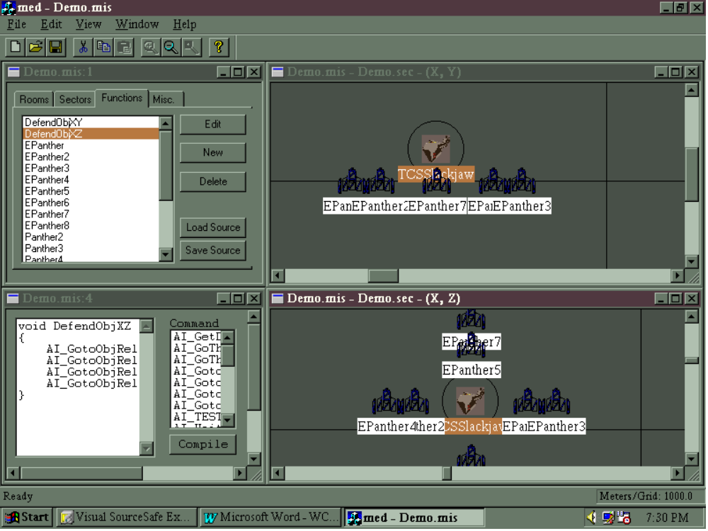

Certainly looks prettier than the previous method, eh?

QUICK START/TUTORIAL:
This will guide you through the creation of a moderately complex mission.

Opening a mission:
To open a mission, select Open from the File menu, and find the correct directory and file name for the mission you want to see. After this is done you will see a menu with four tabs across the top.

Rooms is for editing a gameflow screen (later).
Sectors displays a list of sectors used in the mission file.
Functions displays a list of Functions defined in the mission (User-defined and object programs).
Misc. is open for discussion, but for right now allows you to edit the mission properties.

Click on the Sectors tab, and select Demo.sec. Either double-click on it or click once on the file name, then click Edit.

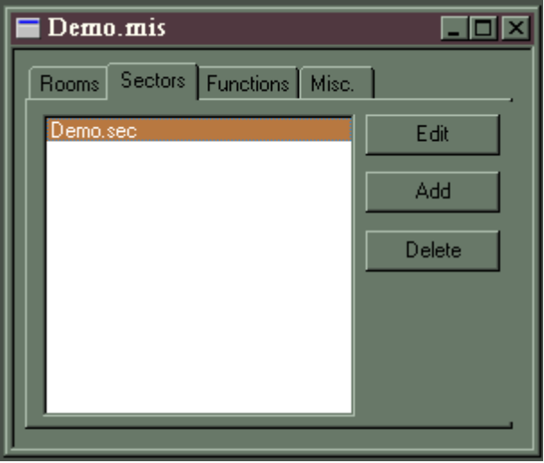

MENU BARS:
These are the menus as they appear when editing a sector, a mission sector, or a function.

FILE: *
NEW  [CTRL-N] | Create a new mission file.
OPEN  [CTRL-O] | Open any file in your local WC directory. Eventually these files will be SourceSafed, and will only be editable if checked out.
CLOSE | Close the mission file. Prompt to save if it has not been done.
SAVE  [CTRL-S] | Save current mission file.
SAVE AS | Save the mission file under another name.
1 … 4  QUICK  LOAD | (as with WORD) The last four mission/sector files accessed are listed here. Click on the file name or press the number (1, 2, 3, or 4) to open that file.

EDIT:

UNDO  [CTRL-Z] | Reverses certain commands or deletes the last entry you typed.
REDO  [CTRL-Y] | Reverses the Undo
CUT  [CTRL-X] | Removes selected object from EDITOR BOX and puts it on the editor clipboard. This can be an object, a light, or a string of text. The editor cannot currently put a variable or a function into the clipboard.
COPY  [CTRL-C] | Copies selected objects to the editor clipboard.
PASTE  [CTRL-V] | Places an object from the editor clipboard to EDITOR BOX.
INSERT  [INS] | Brings up the list of available objects. Double click on an object’s name to select that object, and click on the sector view to place that object.
DELETE  [DEL] | Selected object is removed

VIEW:

TOOLBAR | Displays the toolbar across the top of the editor.
STATUS BAR | Displays the status bar along the bottom of the editor.
VARIABLES | Opens up the Variable window, which contains a list of all available global variables.
OBJECT PALETTE | Opens the Object Palette, which displays, in icon form, all available objects to be placed in the world.
REFRESH | (Sector view only) Refreshes the currently selected window.
PREFERENCES | Opens up the Preferences window, allowing the user to select the label font.
FORMAT | Opens the Format menu, allowing the user to define the grid size.
ZOOM IN | Puts the mouse cursor in Zoom In mode.
ZOOM OUT | Puts the mouse cursor in Zoom Out mode.

WINDOW:
NEW WINDOW | (Sector view only) Allows the user to open an additional window showing the same sector from a different point of view.
CASCADE | Cascades the windows currently open. Classic Windows.
TILE | Tiles the windows currently open. Classic Windows.
QUICK  VIEW (1, 2, 3, etc.) | (as with WORD) All currently usable windows are listed here. Click on the file name or press the number (1, 2, 3, etc.) to open that file.

HELP:
ABOUT | Currently lists the programmer’s name along with a version number.

*The BOLD underlined letter means this option can be accessed in the editor by holding the [ALT] key and the underlined letter.

Events

Main Program
When an object is created, the Main Program is run until a conditional within the Event Handler has been met. At that point an event is run according to priority.

Event Handler
The conditions listed in the object’s Event Handler are checked every game loop. When the conditions are met, events are executed according to priority.

Events 0, 1, 2, & 3
Each ship has four slots for events, which default to NULL. The events are numbered from 0 to 3, with 0 being the highest priority. For example, If the conditions required to run Event 3 are met, it is run until it ends and returns control back to the Main Program. But if the conditions required to run Event 0 are met before Event 3 is finished, Event 0 will immediately begin to run until it is finished or is halted by the Event Handler.

TimeRange
At this time (absolute mission time) run these ScriptCommands

Logic Operations
if (FlagName)
{
ScriptCommand1
ScriptCommand2
}
else
{
ScriptCommand1
ScriptCommand2
}

if (conditional)
{
ScriptCommand1
ScriptCommand2
}
else
{
ScriptCommand1
ScriptCommand2
}

Object Behavior

Script Commands

Pre-defined Functions
long(?) AI_GetDistance(_ObjId obj)
void AI_GoThruObjRelFrame(_ObjId obj, int i, int j, int k)
void AI_GoThruObjRelWorld(_ObjId obj, int I, int j, int k)
void AI_GotoObj(_ObjId obj)
void AI_GotoObjRange(_ObjId obj, int range)
void AI_GotoObjRelFrame(_ObjId obj, int i, int j, int k)
void AI_GotoObjRelWorld(_ObjId obj, int i, int j, int k)
? AI_TEST_Face (?)
void AI_WaitMilliseconds(int(?) milliseconds)
void AI_WaitSeconds(int seconds)
? MCP_RunMission(?)
? MS_RunGameflow(?)
? MS_RunSpaceflight(?)
? SYS_Clock(?)
void SYS_EventDisable(int event)
void SYS_EventDisable_All(void)
void SYS_EventEnable(int event)
void SYS_Event_Set(int event)
void SYS_Fatal(void)
void SYS_PlaySFX(_WaveFile wav)
void SYS_PlaySFXObj(_WaveFile wav)
long(?) SYS_TimerGet(void)
void SYS_TimerSet(int seconds)
long(?) SYS_TimerZero(void)

User Defined Functions
These are functions written by the designer, for the designer. They are made up of Pre-defined Functions, and may pass and return values of any type. Think of it as a sort of macro system. Local variables can be declared in a User-Defined function the same as in a conventional function.

User-Defined Function DefendObjXZ (orders an object to do a four-point circle around object obj, each point of which is radius rad from the center point of obj.

void DefendObjXZ (_ObjId obj, int rad)
{
AI_GoThruObjRelFrame(obj,rad,0,0);
AI_GoThruObjRelFrame(obj,0,0,rad);
AI_GoThruObjRelFrame(obj,-rad,0,0);
AI_GoThruObjRelFrame(obj,0,0,-rad);
}

Object Panther’s Main Program, which calls Function DefendObjXZ
void Panther ()
{
@1
DefendObjXZ(TCSVictory, 150);
goto @1
}
These are not yet implemented.
Attack(TargetObject) and Attack(TargetObject, WithinRange)
MustAttack(TargetObject) //Ignore all other enemies
PriorityAttack(TargetObject1, TargetObject2, TargetObject3)
Defend(TargetObject or Location) and Defend(TargetObject or Location, WithinRange)
PriorityDefend(TargetObject1, TargetObject2, TargetObject3)
Ignore(EnemyType) and Ignore(Target1, Target2, etc.)
Harass(TargetObject, Location) //Attack, then lure to location
Evade(EnemyType) and Evade (TargetObject)
Patrol(Location, Location, Location, etc.) and Patrol(Location, Location…WithinRange, Speed)
Goto(Location, WithinRange) and Goto(Location, Speed)
MustGo (Location)
SetWingman(TargetObject) and SetWingman(TargetObject, RelativePosition:X,Y,Z)
Follow(TargetObject)
ActivateObject(TargetObject or Area) and ActivateObject(TargetObject, RelativePosition:X,Y,Z)
DeactivateObject(ObjectName)
SetObjectPropertyFlag(ObjectFlag)
ClearObjectPropertyFlag(ObjectFlag)
JumpIn(Object, Location)
JumpOut(Object, Location)
Launch()
Land(Object) and Land(Object, BayNumber)
Dock(Object)
Undock()
SendComm(CommMovieName) //Separate system to handle comm branching
SuppressMessages(CastMember)
PlaySfx(SfxName)
PlayMovie(MovieName)
Wait(Seconds)
Create(ObjectType, X, Y, Z) and Create(ObjectType, RelativeObject, Xoff, Yoff, Zoff)
CreateWave(GroupName) and CreateWave(GroupName, RelativeObject, Xoff, Yoff, Zoff)
Tractor(TargetObject)
SwitchCamera(NewPosition)
TestObjectPropertyFlag(ObjectFlag)
Eject()

Flags

Global Variables
There are two ways to declare a global variable:
- Click on Variables in the View menu, click on the mission name (Demo.mis), and hit Ins. A window will open up asking for the name of the variable and its type. The character limit is X characters, and only letters and numbers can be used; no white space or symbols will be tolerated.
- Simply declare the variable above a function. During the compile, The variable will be removed from the function itself and placed in the list of global variables.

int counter;

void MyFunct ()
{
counter += 1;
}

Local Variables
To declare a local variable within a function, simply declare it within the bounding brackets of that function.

Object Properties

Scripting Syntax

Logic
Used to compare flags, variables, and function returns. Evaluate to determine which script commands run. Comparisons can include object property flags/variables, timer values, local and global mission flags, and function return values.

Logical expression ? expression (script command) : conditional expression (script command)

- If / else
<,>,<=,>=, ==, !=

