Wing Commander Prophecy: Secret Ops

Addendum to:

Joan’s Fighting Personnel
&
Joan’s Fighting Spacecraft
WCP: Secret Ops
Addendum to:

JOAN’S FIGHTING Personnel
MAIN CHARACTER WINGMAN STATS:

Amber “Amazon” Elbereth:
- Loyalty: 4
- Gunnery: 4
- Flying: 5
- Ejection: 0
- Verbosity: 4
- Squadron: << CLASSIFIED >>

Max “Maestro” Garret:
- Loyalty: 4
- Gunnery: 5
- Flying: 4
- Ejection: 0
- Verbosity: 4
- Squadron: << CLASSIFIED >>

Karl “Spyder” Bowen:
- Loyalty: 4
- Gunnery: 5
- Flying: 5
- Ejection: 0
- Verbosity: 4
- Squadron: << CLASSIFIED >>

Jean “Stiletto” Talvert:
- Loyalty: 5
- Gunnery: 5
- Flying: 4
- Ejection: 0
- Verbosity: 4
- Squadron: << CLASSIFIED >>

Terrence “Zero” O’Hearn:
- Loyalty: 4
- Gunnery: 4
- Flying: 5
- Ejection: 0
- Verbosity: 5
- Squadron: << CLASSIFIED >>

WCP: Secret Ops
Addendum to:

JOAN’S FIGHTING SPACECRAFT

Section I: The Fighters

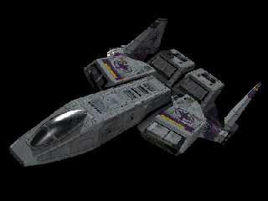
F-103-D Excalibur
Mass : ~18 metric tonnes
Core Damage Points: 200

Velocity:
Max: 650
Normal: 500
Min: 165

Engines:
Engine Acceleration: 275
Afterburner Acceleration: 1800
Afterburner Velocity: 1300
Afterburner Duration: 240
Max Pitch: 70
Max Yaw: 75
Max Roll: 70
Rotational Acceleration: 200

Shields:
Shield Power: 600
Shields Front: 300
Shields Rear: 200
Recharge Rate:
Max: 30
Normal: 20
Min: 8

Armor:
Front: 110
Rear: 110
Left: 110
Right: 110

Guns: 4 x Tachyon Cannon, 2 x Ion Cannon
Gun Power: 400
Recharge Rate:
Max: 78
Normal: 60
Min: 12

Missiles: 4 x Spiculum IR, 4 x Pilum FF

Decoys: 36

Variant Loadouts:
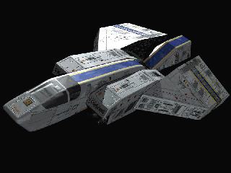
F-66-D Thunderbolt VII
Mass : ~20 metric tonnes
Core Damage Points: 200

Velocity:
Max: 494
Normal: 380
Min: 114

Engines:
Engine Acceleration: 250
Afterburner Acceleration: 1200
Afterburner Velocity: 1000
Afterburner Duration: 200
Max Pitch: 50
Max Yaw: 50
Max Roll: 50
Rotational Acceleration: 180

Shields:
Shield Power: 550
Shields Front: 300
Shields Rear: 250
Recharge Rate:
Max: 25
Normal: 17
Min: 3

Armor:
Front: 120
Rear: 120
Left: 100
Right: 100

Guns: 2 x Tachyon Cannon, 4 x Ion Cannon
Gun Power: 350
Recharge Rate:
Max: 79
Normal: 60
Min: 7

Missiles: 3 x Pilum FF, 3 Valiant LT, 1 x 24 Dragonfly RP

Decoys: 36

Variant Loadouts:

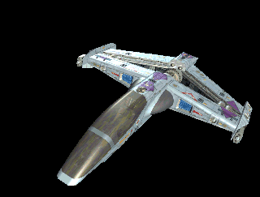
F-106-C Piranha
Mass : ~12 metric tonnes
Core Damage Points: 160

Velocity:
Max: 650
Normal: 500
Min: 150

Engines:
Engine Acceleration: 650
Afterburner Acceleration: 1800
Afterburner Velocity: 1400
Afterburner Duration: 360
Max Pitch: 90
Max Yaw: 90
Max Roll: 135
Rotational Acceleration: 220

Shields:
Shield Power: 420
Shields Front: 210
Shields Rear: 210
Recharge Rate:
Max: 30
Normal: 20
Min: 2

Armor:
Front: 250
Rear: 200
Left: 220
Right: 220

Guns: 3 x Ion Cannon
Gun Power: 280
Recharge Rate:
Max: 45
Normal: 30
Min: 3

Missiles: 2 x Spiculum IR, 4 x Javelin HS

Decoys: 24

Variant Loadouts:
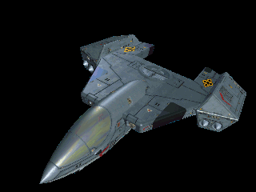
F/A-105-B Tigershark
Mass : ~ 14 metric tonnes
Core Damage Points: 180

Velocity:
Max: 552
Normal: 480
Min: 144

Engines:
Engine Acceleration: 560
Afterburner Acceleration: 1400
Afterburner Velocity: 1200
Afterburner Duration: 360
Max Pitch: 75
Max Yaw: 75
Max Roll: 120
Rotational Acceleration: 195

Shields:
Shield Power: 460
Shields Front: 230
Shields Rear: 230
Recharge Rate:
Max: 34.5
Normal: 23
Min: 2.3

Armor:
Front: 260
Rear: 220
Left: 230
Right: 230

Guns: 4 x Ion Cannon
Gun Power: 275
Recharge Rate:
Max: 52
Normal: 35
Min: 3.5

Missiles: 1x 36 Dragonfly RP, 4 x Javelin HS, 2 x Pilum FF, 2 x Spiculum IR

Decoys: 24

Variant Loadouts:

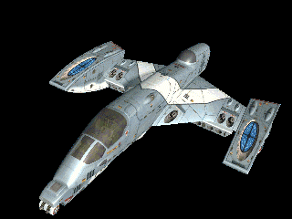
F-109-B Vampire
Mass : ~ 17 metric tonnes
Core Damage Points: 260

Velocity:
Max: 610
Normal: 530
Min: 160

Engines:
Engine Acceleration: 720
Afterburner Acceleration: 1800
Afterburner Velocity: 1500
Afterburner Duration: 360
Max Pitch: 135
Max Yaw: 70
Max Roll: 180
Rotational Acceleration: 280

Shields:
Shield Power: 580
Shields Front: 320
Shields Rear: 260
Recharge Rate:
Max: 42
Normal: 28
Min: 2.8

Armor:
Front: 320
Rear: 320
Left: 320
Right: 320

Guns: 4 x Tachyon Cannon, 2 x Ion Cannon
Gun Power: 500
Recharge Rate:
Max: 90
Normal: 60
Min: 6

Missiles: 8 x Spiculum IR, 8 x Pilum FF, 4 x Tracker MFF

Decoys: 48

Variant Loadouts:

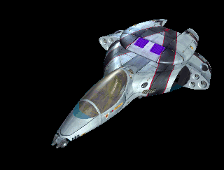
F-108-S “Black” Panther
TCIS Modified "Black" Panther
Mass : ~16 metric tonnes
Core Damage Points: 200

Velocity:
Max: 600
Normal: 500
Min: 180

Engines:
Engine Acceleration: 530
Afterburner Acceleration: 2200
Afterburner Velocity: 1350
Afterburner Duration: 360
Max Pitch: 65
Max Yaw: 115
Max Roll: 105
Rotational Acceleration: 245

Shields:
Shield Power: 480
Shields Front: 250
Shields Rear: 230
Recharge Rate:
Max: 39
Normal: 26
Min: 2.6

Armor:
Front: 280
Rear: 280
Left: 280
Right: 280

Gun Power: 500
Recharge Rate:
Max: 100
Normal: 75
Min: 10

Guns: 2 x Cloudburst Cannon, 2 x Pulse-Particle

Missiles: 6 x Artemis ELRIR, 6 x Pilum FF
ELRIR (Enhanced Long Range Image Recognition)

Decoys: 36

Variant Loadouts:
"Strike" Loadout:
Missiles: 4 x Artemis ELRIR, 2 Ravager ELRAR, 1 x 36 Mosquito ERP, 2 x Lancer ELT
ELRIR (Enhanced Long Range Image Recognition)
ELRAR (Enhanced Long Range Anti-Radiation)
ERP (Enhanced Rocket Pods)
ELT (Enhanced Light Torpedo)

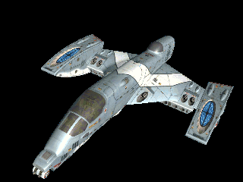
F-109-S “Black” Vampire
TCIS Modified "Black" Vampire
Mass : ~ 17 metric tonnes
Core Damage Points: 260

Velocity:
Max: 700
Normal: 600
Min: 200

Engines:
Engine Acceleration: 720
Afterburner Acceleration: 1800
Afterburner Velocity: 1550
Afterburner Duration: 360
Max Pitch: 140
Max Yaw: 75
Max Roll: 185
Rotational Acceleration: 280

Shields:
Shield Power: 600
Shields Front: 330
Shields Rear: 270
Recharge Rate:
Max: 60
Normal: 40
Min: 4

Armor:
Front: 350
Rear: 350
Left: 350
Right: 350

Guns: 4 x Tachyon Cannon, 2 x Pulse Particle Cannon
Gun Power: 500
Recharge Rate:
Max: 90
Normal: 60
Min: 9

Missiles: 8 x Artemis ELRIR, 8 x Pilum FF, 4 x Tracker MFF

Decoys: 48

Variant Loadouts:
"Strike" Loadout:
Missiles: 6 x Artemis ELRIR, 4 Pilum FF, 1 x 36 Mosquito ERP, 4 x Lancer ELT

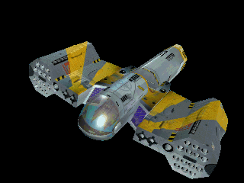
F-110-S “Black” Wasp
TCIS Modified "Black" Wasp
Mass : ~ 18 (12) metric tonnes (without BoosterPod)
Core Damage Points: 200

Velocity:
Max: 700
Normal: 550
Min: 200

Engines:
Engine Acceleration: 590
Afterburner Acceleration: 1600
Afterburner Velocity: 1450
Afterburner Duration: 360
Max Pitch: 80
Max Yaw: 70
Max Roll: 120
Rotational Acceleration: 190

Shields:
Shield Power: 500
Shields Front: 280
Shields Rear: 220
Recharge Rate:
Max: 40
Normal: 30
Min: 6

Armor:
Front: 260
Rear: 260
Left: 260
Right: 260

Guns: 2 x Cloudburst, 2 x Dust Cannon
Gun Power: 600
Recharge Rate:
Max: 90
Normal: 60
Min: 6

Missiles: 8 x Swarmer Packs, 4 x Artemis ELRIR

Decoys: 36
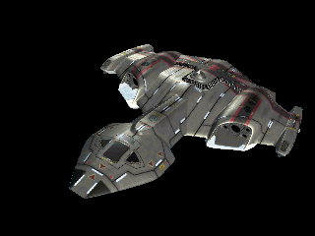
TB-81-S “Black” Shrike
TCIS Modified "Black" Shrike
Mass : ~ 18 metric tonnes
Core Damage Points: 250

Velocity:
Max: 500
Normal: 400
Min: 150

Engines:
Engine Acceleration: 600
Afterburner Acceleration: 1800
Afterburner Velocity: 870
Afterburner Duration: 360
Max Pitch: 75
Max Yaw: 60
Max Roll: 85
Rotational Acceleration: 95

Shields:
Shield Power: 620
Shields Front: 320
Shields Rear: 300
Recharge Rate:
Max: 60
Normal:40
Min: 8

Armor:
Front: 360
Rear: 360
Left: 360
Right: 360

Guns: 2 x Dust Cannon, 3 x Pulse Particle
Gun Power: 320
Recharge Rate:
Max: 65
Normal: 45
Min: 14

Missiles: 4 x Artemis ELRIR, 4 Pilum FF, 1 x 36 Dragonfly RP, 1 x 36 Mosquito ERP, 6 x Lancer ELT, 2 x Pike ET

Decoys: 36

Variant Loadouts:

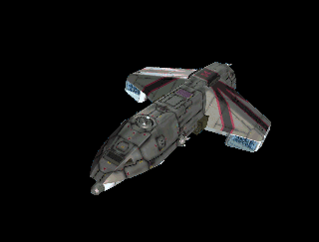
TB-80-S“Black” Devastator
TCIS Modified "Black" Vampire
Mass : ~ 23 metric tonnes
Core Damage Points: 300

Velocity:
Max: 460
Normal: 360
Min: 110

Engines:
Engine Acceleration: 280
Afterburner Acceleration: 900
Afterburner Velocity: 780
Afterburner Duration: 360
Max Pitch: 55
Max Yaw: 65
Max Roll: 90
Rotational Acceleration: 65

Shields:
Shield Power: 850
Shields Front: 450
Shields Rear: 400
Recharge Rate:
Max: 37.5
Normal: 25
Min: 2.5

Armor:
Front: 420
Rear: 420
Left: 420
Right: 420

Guns: 1 x Tachyon Cannon, 1 x Heavy Plasma Cannon
Gun Power: 680
Max: 87
Normal:58
Min: 5.8

Missiles: 6 x Artemis ELRIR, 6 x Pilum FF, 8 x Lancer ELT, 4 x Pike ET, 2 x 36 Mosquito ERP

Decoys: 48
Section II: The New Weapons

Fighter Weapons:
Guns:
Chain Ion Cannon
<Description>

Velocity: 1800 Damage: 20
Range: 2500 Refire Delay: 0.1
Charge(nJ): 15

Pulse Particle Cannon
<Description>

Velocity: 6500 Damage: 30
Range: 6500 Refire Delay: 0.1
Charge(nJ): 15

Dust Cannon
<Description>

Velocity: 10,000 Damage: 40
Range: 5000 Refire Delay: 0.05
Charge(nJ): 18

Cloudburst Cannon
<Description>

Velocity: 3200 Damage: 100
Range: 3900 Refire Delay: 0.45
Charge(nJ): 60

Plasma Cannon
<Description>

Velocity: 2600 Damage: 600
Range: 6000 Refire Delay: 2.0
Charge(nJ): 220

Missiles:
**** The only NEW missile in WCP:SO is the ‘Mosquito’ Enhanced Rocket Pod: ****

ERP – “MOSQUITO”
Velocity: 3200 Acceleration: 3200
Duration: 3.0 Lock Time: 0
Lock Range: 6000 Damage: 80
Max Yaw: 30 Refire Delay: 0.35
Max Pitch: 30 Spoof %: 50

The ‘Mosquito’ is a variant of the ‘Dragonfly’ rocket pod system. It has the same basic characteristics as the ‘Dragonfly,’ except the ‘Mosquito’ mounts a smaller version of the Pilum “Friend or Foe” seeker. It does this, however, at the cost of a decreased warhead yield. The added functionality is both a boon and a bane at times, mainly due to the way in which the guidance systems’ targeting sub-routines operate.

Missile addendum:
Several existing missile have now been given official TCN/TCSF designations:

ELRIR – “ARTEMIS”
ELRAR – “RAVAGER”
ELT – “LANCER”
ET – “PIKE”
Cap-Ship Weapons:

Confed:

Dao-Tech Mk4 Heavy Plasma Cannon
<Description>

Velocity: 4000
Range: 25000
Damage: 1400

Dao-Tech Mk2 Heavy Particle Cannon
<Description>

Velocity: 3000
Range: 15000
Damage: 750

Alien:

“Hellbore” Cannon
<Description>

Velocity: ~4000
Range: ~28000
Damage: ~2000

Section III: The Capital Ships

Note: ALL Capital Ships in the Wing Commander Universe have at least a limited ability to carry and support fighters. On most non-carrier class ships, the majority of these fighters may be interceptors with a lesser number of light strike or patrol fighters.

Note: *Ship Names*
While it has long been military tradition to have the first ship in a class be the “Class Name” that is not always the case. In some instances the “Class Name” may only appear on test hulls or design sketches and construction contracts and hence may never be used on ‘active’ vessels.
It has also been tradition that all vessles in a class bear similar names, alas this is also not always the case. It is true that many ships within the class may have related names, but it is not uncommon for ships with totally dissimilar names to be commisioned within the class. It is also not totally unheard of for ships to be renamed when assigned to certain battle-groups, the new name often being associated with the flagship of that group in one way or another.

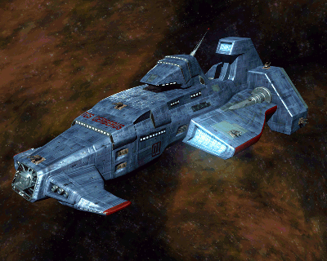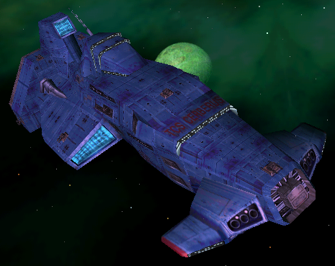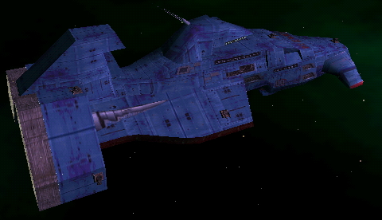
TCS Cerberus - “Hades” Class Strike Cruiser (TCIS):
Ships: TCS Hades (Initial prototype), TCS Cerberus
Length: 777m
Max. Cruise Velocity: 350 kps
Crew: 150* naval (CIS) crewmen. **
Max. Fighter Compliment: 30
Shuttles: 4
Armament:
1 x Mk4 Heavy Plasma Cannon - 2000 DP
10 x Dual Mount Tachyon Cannon – 800 DP
4 x Single Mount Heavy Laser Cannon – 800 DP
2 x Dual Mount Anti-Fighter Missile Turret – 800 DP
6 x Ship-to-Ship Torpedo Launchers – N/A
Bridge: 3000 DP
Landing Bay: 3000 DP
Launch Tube: 3000 DP
Engine (x2): 3000 DP

The ‘Hades’ Strike Cruiser Program might well have been canceled years ago if not for the ‘official’ support it received from within the Intelligence branches of the Confederation and a few other, more public government sources. In its initial stages of development, the ‘Hades’ program was staggeringly over-budget, at times rivaling even the production costs of the new ‘Midway’ class carriers. Some sources outside of the Confed Military have attributed these costs to the CIS’s involvement in the project, speculating that these additional funds were actually being channeled for use by the CIS in other endeavors. The Navy’s public endorsements of the ‘Hades’ program has previously been described as ‘grudging’ or ‘forced’ at best, lending even more support (at least in the minds of those who obsess on such things) to the theories that the whole project is just back-handed method of funding for the CIS. However, with the recent announcements of the completion of two prototypes, (only one, the ‘Cerberus’ having ever been seen in the public news channels) the validity of the Navy’s continued stance that the ‘Hades’ project is “An integral part of our plans for the future..” seems to be gaining strength, at least in the minds of the general populace.

*Including pilots and support staff for fighter detachment.
**The “Hades” class also has the ability to transport and deploy 2 Marine LCs and two Companies of Marines, but this requires a smaller fighter complement aboard.

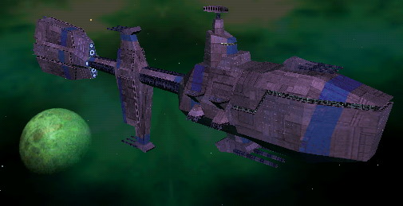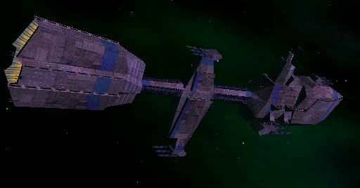
“Plunkett” Class Cruiser

Ships:
TCS Plunkett, TCS Farnahm, TCS Cernan, TCS Borman, TCS Haise, TCS Mitchell, TCS Bannockburn, TCS Adelaide, TCS Tereshkova, TCS Rukavishnikov, TCS Ivanov, TCS Popov, TCS Farkash, TCS Kubasov, TCS Aksyonov, TCS Pytlivy, TCS Raduga, TCS Rastoropny, TCS Razitelny, TCS Razyashchy, TCS Razumny, TCS Resitelny, TSC Retivy, TCS Revnostny, TCS Rezky, TCS Mogami, TCS Kumano, TCS Mikuma, TCS Atago, TCS Takao

Length: 1200m
Max. Cruise Velocity: 240 kps
Crew: 800
Max. Fighter Compliment: 15
Shuttles: 5
Armament:
1 x Triple Mount Mk4 Heavy Plasma Cannon – 1500 DP
3 x Triple Mount Mk2 Heavy Particle Cannon – 1200 DP
6 x Dual Mount Tachyon Cannon – 800 DP
15 x Dual mount Laser Heavy Laser Cannon – 800 DP
Bridge: 2800 DP
Engine: 3300 DP

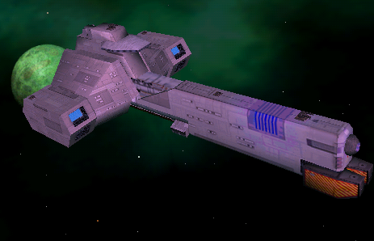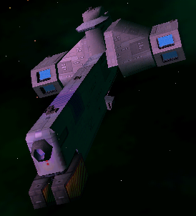
“Murphy” Class Destroyer –

Ships:
TCS Murphy (Initial Prototype), TCS Falchion, TCS Foehammer, TCS Soulcutter, TCS Wayfinder, TCS Farslayer, TCS Vanguard, TCS Avenger, TCS Leon, TCS TCS Miller, TCS Pugh, TCS Wallingford, TCS Leonov, TCS Kuznetsova, TCS Arkhangelsk, TCS Lazarev, TCS Lebedev, TCS Khrunov, TCS Feokstitov, TCS Beregovoi, TCS Nikolayev, TSC Grissom, TCS Glenn, TCS Gordon, TCS Griggs, TCS Cooper, TCS Stafford, TCS Sullivan, TCS Payton, TCS Kiri, TCS Ume, TCS Kaba, TCS Odake, TCS Shii, TCS Onizuka, TCS Miohishio

Length: 589m
Max. Cruise Velocity: 240 kps
Crew: 450
Max. Fighter Compliment: 8
Shuttles: 3
Armament:
1 x Centerline Hull Mount Mk4 Heavy Plasma Cannon – N/A ***
3 x Dual Mount Heavy Laser Cannon – 800 DP
4 x Single Mount Heavy Laser Cannon – 800 DP
2 x Dual Mount Anti-Fighter Missile Turret – 800 DP
Bridge: 2500 DP
Engine (x2): 2500 DP
*** Not currently reflected in the game.. –JPG 12 July

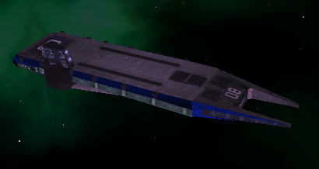
“Vesuvius” Class Fleet Carrier – ( a.k.a. ‘Super’ Carrier )
Ships: TCS Vesuvius, TCS Mt. St. Helens, TCS McKinley, TCS Fuji, TCS Kilauea, TCS Rainier
Length: 1800m
Max. Cruise Velocity: 200 kps
Crew: 4500
Max. Fighter Compliment: ~400
Shuttles: 24
Armament:
2 x Hull Mounted Anti-Matter Guns – N/A***
24 x Dual Mount Heavy Laser Cannon – 800 DP***
4 x Dual Mount Anti-Fighter Missile Turret – 800 DP***
Bridge: 2500 DP
Engine (x3): 2500 DP
Hangar: 2500 DP

*** Not currently reflected in the game.. but since you never see it in a mission.. shouldn’t be an issue.. –JPG 12 July

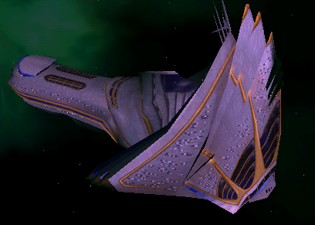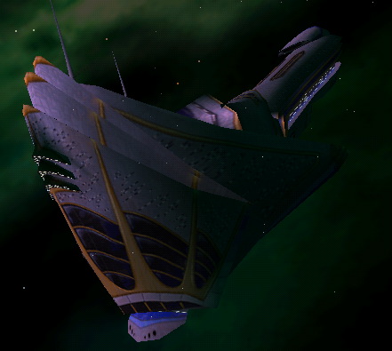
RUSS Industries Civilian Luxury Star-Liner
Ships: Twilight Purchase, Anna Maria Alberghetti, Blue Horizon
Length: 1320m
Max. Cruise Velocity: 200 kps
Crew Compliment: 1200
Passenger Compliment: 5000
Transit Shuttles: 30 (50 persons ea.)
EvacPods: 300 (20 persons ea.)
Pleasure Skiffs: 10 (20 persons ea. +10 crew)
Bridge (x2): 2000 DP
Engine: 2000 DP
Hangar: 2000 DP

Section IV: The Bases

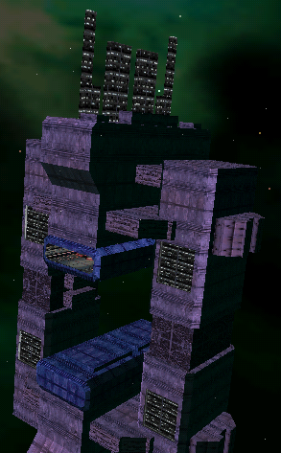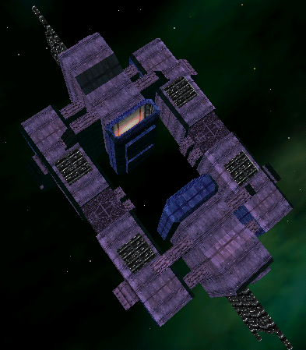
‘New Ella’ – Confed Starbase
Height: ~4000m
Crew Compliment: 10000
Additional personnel support available: 3000
Max Fighter Compliment: 500
Shuttles: 100
Bridge (x8): 2500 DP

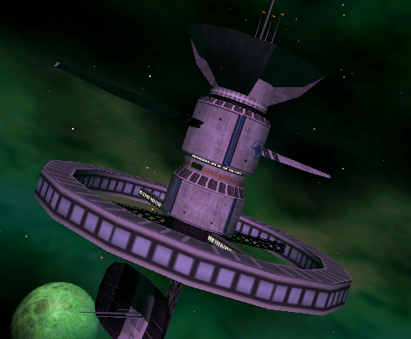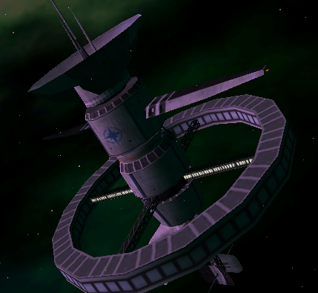
Confed Outpost
Height: ~ 1500 m
Crew Compliment: 1500
Additional personnel support available: 500
Max Fighter Compliment: 50
Shuttles: 50
Bridge: 2000 DP
Antenna (x3): 1000 DP
Hangar: 2000 DP**

** current missing in the game, hopefully will be fixed by release… -JPG 12 July
Section IV: Additional Addendum

The ‘OLD’ Stuff

*NOTE *
EVERYTHING BELOW
IS WORK IN PROGRESS
* NOTE *
WC1, WC2, WC3, WC4, WC:P

WC:A, WC:P

Fighters:

Hornet
Rapier
Scimitar
Raptor
Ferret*-C
Epee-C
Rapier
Rapier II-G
Sabre-A
Arrow
Hellcat Va
Hellcat Vb
Hellcat Vc
Thunderbolt VIIa
Thunderbolt VIIb
Thunderbolt VIId
Excalibur-A
Excalibur-C
Excalibur-D
Banshee*
Razor*
Bearcat
Dragon*
Vindicator*
Pirahna-A
Pirahna-B
Pirahna-C
Tigershark-A
Tigershark-B
Tigershark-W
Panther-A
Panther-B
Panther-W
Panther-S
Vampire-A
Vampire-B
Vampire-W
Vampire-S
Wasp-A
Wasp-B
Wasp-C
Wasp-S
Bombers
Broadsword-D
Avenger*
Longbow-A
Longbow-B
Shrike-A
Shrike-S
Devastator-A
Devastator-S

Capital Ships:

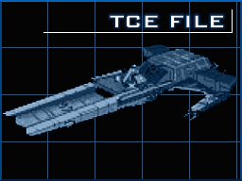

“Bengal” Class Strike Carrier
Ships: TCS Bengal (Prototype), TCS Tiger’s Claw, TCS Kipling
Length: 700
Cruise:
Crew:
Max.
Shuttles:
Armament:

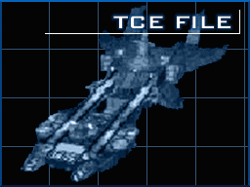

“Confederation” Class Dreadnought –
Ships: TCS Confederation, TCS Concordia
Length: 983.7m
Cruise
Crew:
Max.
Shuttles:
Armament:

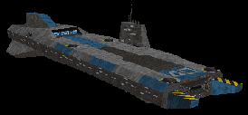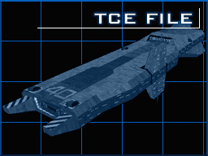

“?” Class Light Carrier
Ships: TCS Victory, TCS Liberty
Length: 720m
Mass:
Cruise: 120kps
Crew:
Max. Fighter Comp: 50
Shuttles: 5
Armament:

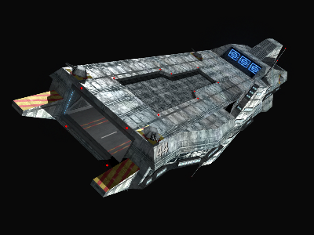

“Concordia” Class Fleet Carrier
While outwardly similar to the “?” class CVL, the Concordia is a much newer and larger carrier.
Ships: TCS Lexington, TCS Eisen, TCS Princeton
Length: 950m
Cruise
Crew:
Max. Fighter Comp: 105
Shuttles: 8
Armament:

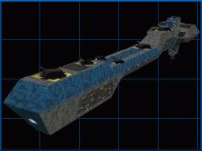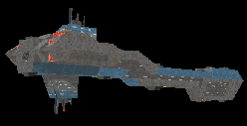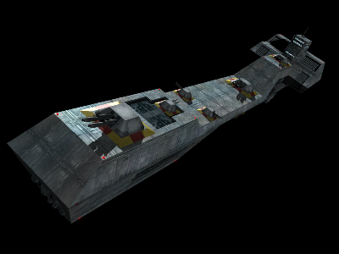

“?” Class Cruiser
Ships: TCS Ajax
Length:
Cruise
Crew:
Max.
Shuttles:
Armament:

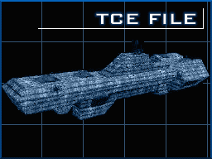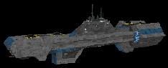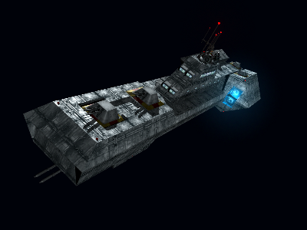

“?” Class Destroyer
Ships: TCS Coventry, TCS Sheffield
Length:
Cruise
Crew:
Max.
Shuttles:
Armament:

“?” Class Corvette – TCS Venture
“?” Class Destroyer – TCS Exeter
“?” Class Destroyer – TCS Paradigm
“?” Class Destroyer – TCS Gilgamesh
“?” Class Cruiser – TCS Waterloo
“?” Class Frigate – WC3
“?” Class Frigate – WC4

“Drayman” Class Transport
“Free Trader” Class Transport
“Clydesdale” Class Transport
“?” Class Transport – WC3
“Pelican” Class Transport

“Tarsus” ? Class Merchant Scout Vessel
“Centurion” ? Class Bounty Hunter Heavy Fighter
“Galaxy” ? Class Merchant Vessel
“Orion” ? Class Mercenary Gunship
“Demon” Class Mercenary Light Fighter
“Gladius” Class Militia Light Fighter
“Talon” Class Light Fighter – Militia, Pirate, Retro

Dralthi –KLF
Gothri –KF
Kamekh –K Corvette

Bases:

Confed Comm Relay Station - WCP
Confed Outpost – WCP:SO
Confed Starbase – WC2 - Olympus Station
Confed Supply Depot – WC3
Confed Starbase – WC3
Confed Starbase – WC4 - Blackmane

